

**School of Science, Engineering, & Environment**

**MSc Software Engineering**

**“Full Stack E-Commerce Web Application”**

**2023-24**

**Student Name: Jyosthna Reddy**

**Student Id: SDP414**

**Supervisor Name: Abdulhamid Ardo**

# Abstract

With the increased prevalence of the Internet and digital technologies, e-commerce has emerged in most industries to let customers purchase their desired products or services online at their convenience. E-commerce applications are continuously evolving due to increased technological advancements. Nowadays, customers prefer ease and convenience, particularly during shopping. Online shopping has been increasinhly emerged to let the cystomers make shopping conveniently with an ability to select and compare the desired products and prices to make most reasonable purchases. This research considers the main problems faced by users related to their preferred payment options as per geographic regions and robust security measures for improved data protection. Thus, this research mainly aims to develop a robust and scalable full-stack e-commerce website to enhance the user experience and increase their satisfaction level throughout the shopping journey. In this research, the most advanced technologies, such as Java, Springboot, Angular, and MySQL are used to make the developed website highly efficient, intuitive, scalable, and user-friendly to enhance the overall shopping experience. This e-commerce has a multiple payment options feature to let the customers make payments using their preferred mode of payment. Further, this system has robust security measures to safeguard against security threats and vulnerabilities to protect the user’s sensitive data and information for ultimately building trust among customers and making strong relationships with them.

# Acknowledgment

I would like to express my heartfelt gratefulness to everyone who guided, motivated, and supported me during this whole research. First, I am feeling highly obliged to my Supervisor [Abdulhamid Ardo] for their priceless learning, guidance, motivation, and support throughout the research. His expertise was instrumental in the successful completion of this research project.

I would also like to extend my gratitude to the technical team members, whose expertise in selected Java, Angular, MySQL, and Springboot technologies helped in the development of the e-commerce website. I am grateful to all the technical and academic resources for providing me necessary information, knowledge, and insights to successfully complete this research.

I am also thankful to family and friends for their unwavering love and support during this research. Their belief in my abilities kept me motivated throughout this research.

Table of Contents

Abstract 2

Acknowledgment 3

1 Introduction 7

1.1 The Motivation and Background of the Research 7

1.2 Problem Statement 8

1.3 The Aim and Objectives 9

1.3.1 Aim 9

1.3.2 Objectives 9

1.4 A Summary of the Project Plan 9

1.5 Approach Adopted 9

1.6 Ethical Considerations 10

1.7 Dissertation Structure 11

2 Literature Review 12

2.1 E-commerce Industry, Evolution, Growth, and Challenges 12

2.2 Factors Impact Technological Advancements and Customer Behaviors in e-Commerce 13

2.3 e-Commerce and COVID-19 Pandemic 14

2.4 Core Aspects of Full-Stack Web Development 15

2.4.1 Front-end & Back-end Technologies 15

2.4.2 API Integration 16

2.4.3 Database Management 16

2.5 Security Importance and Associated Challenges with e-Commerce Platforms 16

2.6 Practices and Strategies to Safeguard user’s Sensitive Data while ensuring Transactions’ Integrity 17

2.7 Research Gaps 17

2.8 Conceptual Framework 18

Summary 19

3 Methodology 20

3.1 Research Methodology 20

3.1.1 Research Approach 20

3.1.2 Research Strategy 20

3.1.3 Data Collection 21

3.1.4 Data Analysis 21

3.2 Experimental Methodology 21

3.2.1 Software Development Methodology 21

3.2.2 Process 22

3.2.3 Tools 22

3.2.4 Standards 23

3.2.5 Techniques 24

Summary 25

4 Requirements and Design 26

4.1 Requirements 26

4.1.1 Functional Requirements 26

4.1.2 Non-Functional Requirements 28

4.1.3 Minimum Viable Product (MVP) 28

4.1.4 Requirements by Increment 28

4.2 Design 29

4.2.1 Low-level Design 29

4.2.2 High-level Design 30

5 olution Implementation and Deployment 32

5.1 Hardware 32

5.1.1 Local Development Setup 32

5.1.2 Hardware for Deployment 32

5.2 Networks 33

5.2.1 Network Topology 33

5.2.2 Cloud-Hosted Server Topology 33

5.3 Storage 33

5.3.1 Entity Relationship Diagram 33

5.4 Software 34

5.4.1 Programming Language 34

5.4.2 Class Diagram 35

5.4.1 Object Sequence Diagrams 35

5.4.2 System Development 36

6 Solution Evaluation 45

6.1 Test Plan 45

6.1.1 Unit Testing 45

6.1.2 End-to-end Testing 45

6.2 Test cases 45

6.3 Test Results 46

7 Critical Evaluation 48

7.1 Evaluation against Objectives 48

7.1.1 Developing a robust e-commerce web platform 48

7.1.2 Employing advanced technologies 48

7.1.3 Assessing the existing e-commerce technologies 48

7.1.4 Analyzing multiple payment options 48

7.1.5 Deploying effective security measures 48

7.2 A review of the plan and explanations for any deviations from it 49

7.3 Lessons learned during the project 49

8 Conclusion and Future Work 51

8.1 Conclusion 51

8.2 Limitations 51

8.3 Future work 51

9 References 53

# Introduction

This chapter introduces this research in detail. It first provides a research background and motivation behind this research study. Then it provides a problem statement to discuss the problem that this research considered and answered. Then it provides the research aim and objectives with a project plan summary and adopted approach to conduct this research. Then it provides a brief discussion of the ethical considerations and report structure for this research.

## The Motivation and Background of the Research

Online shopping is a relatively new global phenomenon that can be considered a significant aspect of consumer behavior driven by the accessibility provided by digital platforms. Consumers embrace e-shopping as a primary method of purchasing goods due to its flexibility and ease (Rehman et al., 2022). The shift in the behavior of consumers toward online purchasing has led to an enhanced need for well-developed e-commerce sites that are secure, easy to navigate, and safe.

The rapid increase in online shopping can be attributed to various factors. Firstly, the increasing use of smartphones and access to the internet enables consumers to shop from the comfort of their homes at their convenience. Secondly, COVID-19 has drastically impacted consumers’ purchasing behavior due to restrictions which led to limited accessibility to physical stores (Faqih, 2022). This has made consumers realize the significance of having a robust online platform for the business to survive and maximize profitability. Thus, e-commerce platforms came up with innovative solutions that would improve the overall shopping experience for consumers. This involves an intuitive navigation system, website responsiveness, multiple payment options, excellent visual content, and adequate measures for securing customer’s data. Furthermore, an effective e-commerce platform assists in meeting the standards of the current industry and anticipates future trends thereby having a competitive advantage in the dynamic online marketplace (Mohdhar & Shaalan, 2021).

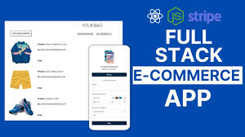

Figure : Full Stack e-commerce App

Source: (Dev Community, 2021)

An analytic and strategic full-stack e-commerce web application is essential in this circumstance. Enabling the use of the latest technologies, it is planned to construct a highly effective and flexible platform that will help to meet consumer expectations. The backend of the application will use Spring Boot (Java) to eliminate instability and encourage scalability. Angular will be used in the front end which helps to offer a responsive, and dynamic user interface. MySQL will act as the database system that helps handle data and ensures scalability (Avramidis, 2022). Such technologies are utilized mainly because they are known to produce robust and effective web applications. Spring Boot is well-known for being relatively easy to use and providing a comprehensive set of tools that assist in developing robust backend services. Angular which is a widely used frontend framework provides a wide range of tools for building interactive, and dynamic user interfaces (Duldulao & Villafranca, 2022). A selected relational database management system like MySQL helps in the proper management, storage, and retrieval of information.

The motivation behind this research is to discuss the problems and opportunities that evolve from the current dynamic environment in e-commerce. A digital marketplace tends to be characterized by constant innovation and increasing competition which resulted in developing advanced e-commerce platforms. These platforms play a very crucial role in meeting the needs of the customers and providing satisfaction beyond their level of expectations (Felix & Rembulan, 2023). The conventional approaches to e-commerce do not meet the expectations and lack in providing a secure, intuitive, and seamless experience demanded by consumers. This gap provides the ideal opportunity to develop a much stronger and dynamic platform that can help meet the evolving needs of consumers.

Developing an advanced e-commerce web application not only helps in addressing the current problems but also foreseeing future trends. The preferences and behaviors of the consumers are changing rapidly which are influenced by various factors like advancements in technology, global events, and changes in social norms (Cruz-Cárdenas et al., 2021). Therefore, by identifying these changes the project aims to create a platform that might not only be productive but also resilient and capable of facing the changes. This effective strategy guarantees that the platform is relevant and can adapt to the dynamics of the market. Furthermore, this research is aimed at improving the overall shopping experience in the marketplace. The presence of a well-designed and developed e-commerce platform can affect the customers’ perceptions and loyalty which results in higher rates of conversion, and boosting sales. Thus, incorporating features like a mobile-first solution, multiple payment options, robust security measures, and high-quality images of the products helps in creating e-commerce solutions that assist in fostering trust, loyalty, and satisfaction. Such an approach helps to address the immediate and long-term expectations of the consumers thereby ensuring a competitive advantage in the digital marketplace (Beyari, 2021). Overall, this research aims to contribute to making advancements in e-commerce technology, delivering a platform that helps in setting new standards for security, adaptability, and user experience.

## Problem Statement

Despite the proliferation of e-commerce platforms, many websites found it difficult to satisfy the current and future needs of consumers. Some of the problems include poor user experience, lack of security measures, lack of mobile optimization, and limited options to make payments continue to invade online shopping websites. These shortcomings lead to reduced consumers, lack of trust, and low profits resulting in low conversion rates for the businesses (Bojjagani et al., 2023). Furthermore, these solutions are normally integrated in an effective way which results in issues in scalability, and inconsistent performance thereby leading to affecting trust, and diminishing satisfaction among the consumers. For instance, Shopify is one of the popular brands in the UK but it does not have robust security measures to secure and protect the available sensitive data.

The primary research issue that this study aims to address is the establishment of an e-commerce platform that helps in overcoming these challenges. The purpose here is to build a full-stack e-commerce web application that provides a secure, user-friendly, and seamless experience across various devices. Utilizing advanced technologies like Spring Boot for backend development, Angular for frontend development, and MYSQL for managing databases. Moreover, the research seeks to deliver a comprehensive solution that complies with the current standards and trends of the industry. It will also emphasize incorporating features like providing support to the consumers, robust analytics for continuous improvements, and offering personalized recommendations. These features will help in retaining, and enhancing the engagement among the consumers. Therefore, the study focuses on critical aspects to provide new benchmarks for the e-commerce platforms and allow them to meet the changing demands of consumers and stay competitive in the digital marketplace.

## The Aim and Objectives

### Aim

This research aims to create a secure, dynamic, and robust full-stack e-commerce web application that helps meet the evolving needs of consumers.

### Objectives

* To examine the existing e-commerce technologies to identify the needs of the consumers towards using e-commerce web applications
* To develop an effective e-commerce platform that provides a seamless user experience across various devices.
* To employ advanced technologies like Spring Boot, Angular, and MySQL to ensure the platform is efficient and can adapt to future needs.
* To integrate multiple payment options that help in meeting the diverse needs of the consumers.
* To implement robust security measures to develop trust and protect customer data.

## A Summary of the Project Plan

The project plan for creating the full-stack e-commerce web application includes several critical steps that will avoid certain pitfalls and ensure the effective development of the program. Firstly, the Requirement Gathering and Analysis phase involves identifying the requirements of the e-commerce platform based on detailed market analysis and the expectations of the consumers (Islam, 2023). This phase provides the framework for the project and defines the features and necessities of the project. Subsequently, the design and architecture phase will develop the overall design, and architecture of the system including database schema, and design of the user interface. The Development phase involves the implementation of Spring Boot for the backend, Angular for the frontend, and MySQL for managing the database. The next stage is the Testing and Quality Assurance phase, which involves identifying defects in the system including functional, performance, and security testing to meet quality standards (Singh, Javed & Dhaliwal, 2022). Finally, the Deployment and Maintenance phase is a critical stage of the process, the application is deployed on suitable cloud platforms like AWS, and Azure thereby maintaining the application’s security, and performance with the standards of the industry. Such an approach helps to design an effective, dynamic, and secure e-commerce web application that will help with the current needs of the consumers and anticipate future trends.

## Approach Adopted

The approach chosen for this research comprises the use of agile methodologies and the best practices in software development. Agile methodologies will be used in ensuring adaptability, and flexibility throughout the process of development. This approach has various advantages including iterative development, constant feedback, and updates thereby ensuring that the products help in meeting the evolving needs of the consumers (Waja, Shah & Nanavati, 2021). The development process will follow an approach of sprints where every sprint will be associated with the features to be developed. However, at the end of each sprint, a review will be done to analyze progress and make necessary adjustments. This approach helps in identifying issues in the process of development thereby minimizing the risks of failures, and delays.

Cloud computing platform provides various advantages like cost-effectiveness, reliability, and scalability. By utilizing cloud infrastructure, it becomes convenient to handle traffic, implement robust security measures, and ensure availability (Alam, 2020). Adherence to modern methodologies of developing software like reviewing codes, testing the software, and integrating the software into the workflow will help in delivering the product of the highest quality. Applying advanced methodologies within the context of best practices proposed by current literature, the project’s goal is to create a secure, effective, and responsive e-commerce web application that anticipates evolving trends and meets the current standards of the industry. Therefore, combining these approaches including agile methodologies, best practices, and cloud computing platforms helps in developing a robust, and secure e-platform web application.

Figure : Approach Adopted

## Ethical Considerations

The major concern when designing an e-commerce web application is ensuring data privacy and security. One of the key ethical responsibilities is to safeguard the customer’s data. To ensure the security of data inside the application strong measures such as encryption, secure payment facility, and security measures must be implemented. Transparency can be considered as the other critical ethical consideration (Moravcsik, 2020). These platforms will play a crucial role in communicating policies related to using data, shipping, maintaining privacy, and returns which helps in fostering trust and developing relations with the customers. Therefore, ensuring that the customers have been informed about how the data will be used and safeguarded is significant to maintain ethical standards. Anonymity helps protect the personal identities of the users and ensures to not disclose them without seeking their permission thereby promoting privacy.

Confidentiality means that all personal information that is received from the users like payments and any other operations with the account should be protected. Data storage and data transfer will be secured using the best encryption methods on the platform (Kang & Hwang, 2023). Sensitive data will be secured using a strong user ID /Password and will not be shared with third-party users. Regular audits and adherence to data privacy laws like the generalized data protection regulation will be done to maintain confidentiality and data integrity.

Another ethical consideration that affects the business is accessibility. The application will be designed and easily accessible by the users having disability following the Web Content Accessibility Guidelines (WCAG). This guarantees that all users can easily understand and find their way around the platform. Lastly, the project will adhere to ethical standards in software development like environmental considerations, and fair practices among labor. Therefore, by following these ethical standards the project is going to provide a robust, trustworthy, and inclusive e-commerce platform.

## Dissertation Structure

* **Introduction**: This chapter provides an overview of the research process and sets the context, by identifying the motivation, background, problem statement, aims and objectives project timeline, the selected approach, the ethical considerations, and dissertation structure.
* **Literature Review:** This chapter presents a review of existing literature on e-commerce web-based applications, the technologies applied, understanding the behavior of consumers, and standards of the industry. It will also help in identifying research gaps and setting the context for the research.
* **Methodology:** The purpose of this chapter is to describe the research carried out in terms of the process of design and development, methods of collecting data, and analyzing techniques used in the research. It outlines the process through which the research will be carried out and the justification for selecting the selected methods.
* **Requirements and Design:** This chapter describes the specification of the e-commerce platform and the process of design. It includes designing a user interface, architecture of a system, and database schema thereby ensuring all the components seamlessly.
* **Solution Implementation and Deployment:** This chapter focuses on discussing the implementation of the e-commerce web application including development, testing, and deployment. It offers information on how the application was developed and the challenges involved.
* **Solution Evaluation:** This chapter will discuss the e-commerce platform’s functionality, usability, security, and scalability of the application. It involves taking feedback from the users and the results that have been recorded concerning the success of the application.
* **Critical Evaluation:** This chapter will critically evaluate the strengths and limitations of the research. It also emphasizes the lessons learned and offers recommendations to make improvements in the future.
* **Conclusion and Future Work:** This chapter summarizes the findings of the research thereby focusing on the contributions. It also outlines key areas for future research and development which help in making improvements in the development of full-stack e-commerce web applications.

# Literature Review

This chapter conducts a detailed literature review for the research based on the development of a full-stack eCommerce web application. This chapter reviews the existing and relevant research papers and journal articles to get a better understanding of this research topic. This chapter will discuss different aspects, such as the latest trends in the e-commerce industry, factors that impact technological advancements in this industry, and customer behaviors (Rodríguez-Ardura et al., 2008). This chapter will deep-delve into the core facets of the development of full-stack web applications, including the front-end & back-end technologies, API integration, and database management with a key consideration on the associated security and privacy issues & challenges with the e-commerce platforms with the most effective strategies to safeguard the user’s sensitive data. Further, this chapter will explore the significance of a highly responsive and dynamic web design to enhance the user-service experience.

## E-commerce Industry, Evolution, Growth, and Challenges

E-commerce term stands for ‘Electronic Commerce’, which means that businesses are transacted through internet-enabled electronic mediums. E-commerce has emerged as the extreme transformative force fuelled by the increasing use of smartphones, the internet, reasonable data prices, and higher purchasing power of customers. It provided a great competitive edge to today’s organizations and businesses. It represents a disruptive force by fetching significant changes and modifications to the existing business models that lead to enhanced customer service experience and satisfaction. E-commerce has huge impacts on several industries, such as banking, traveling, retailing, healthcare, media, and advertising that experience the offered benefits by the e-commerce industry. Since the last two decades, the increased evolution of Internet and web technologies has witnessed the increased advent and adoption of e-commerce. It represents a key part of the information technology revolution that is comprehensively utilized across the global trade in the worldwide economy. It refers t cutting-edge technology as the globalization symbol to revolutionize the ways in which organizations conduct their business operations across the globe. Internet commercialization has significantly driven electronic commerce to become one the most efficient and proficient platforms for better-performing inter-organizational business operations. (Ray, 2011) addresses a snapshot of the increased emergence of e-commerce that denotes a chronological order, comprising the e-commerce business categories, organizational descriptions, firm’s key characteristics for better assessing the increased growth of e-commerce platforms in both financial and physical contexts for efficiently evaluating the attaining business benefits with a critical analysis of the associated constraints or barriers in the adoption of e-commerce.

These days there is a complete change in shopping trends due to increased usage of the internet and social media platforms. The initiation of e-commerce has redefined the ways and experiences of customers while shopping by redeeming the customers from geographical limitations and offering them supreme convenience. E-commerce lets customers explore a comprehensive range of diverse products and services, read user reviews, compare prices, and make purchases with just a few clicks. This drastic shift has provided an efficient way for customers toward the global marketplace by allowing businesses to reach out to customers across diverse cultures and borders (Kang & Hwang, 2023). The growing customer behaviors in the e-commerce industry are largely devoted to the influence of the internet, mobile devices, digital technologies, data analytics, and social media platforms that are integral parts of the customer’s purchasing journey. Currently, mobile commerce (m-commerce) has largely appeared as the most dominant force to let the customers shop anywhere which largely contributed to blurring the boundaries between the digital and physical retail spaces.

Today customers demand personalized shopping experiences tailored to their needs and preferences. The e-commerce platforms increasingly focus on leveraging data analytics for gathering key insights related to individual shopping behaviors & habits that let the businesses suggest relevant and desired products through tailored marketing campaigns. The evolution of social media platforms is the most drastic change in e-commerce to powerfully influence and shape the customer’s purchasing behaviors and ultimately influence consumer loyalty and brand insights. Further, the introduction of various convenient and secure payment methods to empower the customers by giving them a sense of financial security and control.

Customer acquisition is the most frequent challenge faced by e-commerce businesses due to high competition. The e-commerce platforms continuously strive to grab more customers with diverse types of strategies. The poor performance of an e-commerce platform due to an irresponsive user interface, slow loading, or technical glitches can impact the overall business. The businesses also face issues in integrating all the popular and most frequently used payment gateways by their customers (Odeniran, (2023). However, online transactions are highly vulnerable to cyberattacks and data breaches that might deter potential customers from shopping online. Thus, the e-commerce platforms need to ensure robust security measures and privacy policies to establish credibility and trust among the customers. Further, the e-commerce businesses also largely suffered from issues related to lack of personalization, omnichannel experience, lack of innovation, and lack of scalability. Currently, there are growing concerns among customers related to social and environmental issues. So, businesses need to hold highly sustainable practices while demonstrating a sense of social responsibility to more effectively appealing these value-centered customers to gain a competitive advantage.

## Factors Impact Technological Advancements and Customer Behaviors in e-Commerce

A. Dhanalakshmi et al., (2020) state that any business or organization needs to efficiently obtain, serve, and recall their customers. The increased technological advancements and globalization significantly led toward sustainable business quantum at reasonable prices. The comprehensive reach of e-commerce is beneficial for the development of businesses and organizations. The increased emergence of digital technologies, such as the Internet of Things (IoT), Artificial Intelligence (AI), Big Data Analytics, Blockchain, and Machine Learning (ML) largely revolutionized the proliferation of e-commerce worldwide. These technologies largely facilitate predictive analytics, tailored shopping experience, and improved consumer shopping experience that directly impact the interaction and experience of the customers with the e-commerce platforms. Sardjono et al., (2021) address that the comprehensive adoption of mobile devices and smartphones facilitates m-commerce as the most critical component of e-commerce. Most customers prefer to shop online using their mobile phones. Further, the availability of mobile-based secured payment gateways enables customers to easily make transactions leading to increased use of mobile shopping. The increased demand for personalization across products & services and throughout the shopping journey largely prolifies the deployment of AI and ML technologies for offering personalized shopping experiences. Customers demand speed and convenience during shopping, so technologies that can increase the website loading time along with faster checkout process and shipping methods significantly contribute to enhancing consumer loyalty and satisfaction. The emergence of social media platforms plays a pivotal role in shaping the customer’s purchasing behaviors by serving as the channels to discover the desired products, analyze consumer reviews, and share brand perceptions. Businesses increasingly focus on integrating social media platforms with shopping platforms to let customers directly make purchases on social media platforms.

(Hossain et al., 2023) argues security and privacy concerns are paramount because e-commerce platforms gather a comprehensive amount of consumer data. The increased deployment of secure payment gateways, encryptions, and compliance with data protection laws & regulations build trust among customers by making them feel that their data is secured. Further, AI-enabled fraud detection methods can help individuals and businesses recognize any fraudulent activities. Today customers want highly intuitive and responsive UI/UX design that realizes the need for a single page and progressive web applications along with the support of chatbots, product visualizations, and instantaneous inventory updates to enhance the overall shopping experience of their customers. Moreover, modern customers want a consistent experience during shopping across several channels, such as physical stores, online stores, and social media platforms. Customers increasingly become environmentally and socially aware and prefer brands that consider environmental issues and prioritize sustainability (Almeida Lucas et al., 2023). They prefer ethical practices, including transparent material sourcing, fair trading products, and items free from the cruelty that force the brands and businesses to adhere the environment-friendly business processes. Furthermore, local or global economic conditions, such as employment dates, inflation rates, and throwaway income levels largely influence customer’s buying behaviors. Businesses need to adopt and facilitate dynamic pricing algorithms for moderating their prices as per the customer’s behaviors, market demands, and competition to ultimately control the ways in which customers make buying decisions and observe values.

## e-Commerce and COVID-19 Pandemic

According to Elrhim & Elsayed, (2020), COVID-19 pandemic largely impacted the social dimensions and forced people to stay in their homes. It impacts the demand and supply causing significant supply chain issues in the e-commerce sector. This research investigates the impacts of COVID-19 on worldwide e-commerce firms, including 5 global e-commerce corporations globally as the means of market values and revenues. This research measured using the values of new cases and new deaths due to coronavirus and measurement is taken based on the obtained daily returns of the e-commerce company shared from 15 March 2020 to 25 May 2020. The obtained results from the conducted descriptive analysis demonstrated that the e-commerce firms attain significant positive returns based on the assessed daily returns. The impact of COVID-19 on e-commerce companies depends on the country to which the company belongs.

Kawasaki et al., (2022) addressed the the COVID-19 pandemic largely impacted people’s lifestyles, perceptions, and values. A significant drop has been seen in outdoor activities, such as shopping at local markets, outdoor eating, and trips. This research uses panel data to analyze the changes in the psychological intentions of customers in Japan regarding the use of e-commerce platforms before and after the COVID-19 pandemic. However, there is significant growth has been shown in the utilization of e-commerce platforms after the COVID-19 pandemic but it varies according to the product types. The grocery products demonstrated a significant increment just after this pandemic, whereas the software, DVD, book, and machinery products demonstrated a slight increment after this pandemic. Further, there is a positive relationship between the spent time at home and the significance of e-commerce platforms due to restrictions to shopping from local retailers. If the usefulness of e-commerce platforms continues among the customers, then e-commerce can cover most of the industries to better serve the public.

Alwan et al., (2023**)** argue that the COVID-19 pandemic forces most buyers to come online but it poses adverse impacts on the overall performance of e-commerce platforms. This research study uses a hybrid strategy including both grey relational analysis and grey analytical hierarchy process for evaluating the consequences of the impacts and ranking the strategies, respectively. The obtained research findings addressed that supply chain disruption is the most critical factor impacting e-commerce platforms and expanding of supplier base is the most effective strategy to enhance e-commerce platforms. Dianda & Pandin, (2021) demonstrates the role of e-commerce in economic development during the COVID-19 pandemic. A qualitative descriptive methodology is used and the research data was collected from 19 academic articles and 1 website. The research results demonstrated that the COVID-19 outbreak adversely impacted almost every industry and e-commerce can be considered as a potential way of strengthening the economy (Usas et al., 2021).

## Core Aspects of Full-Stack Web Development

Currently, the webpages are accessed using devices of various sizes that raise an increasing demand for a reusable, easy-to-maintain, and cross-platform to develop the backend and frontend codes for improving the overall development process and proficiency. The use of framework technology provides robust code structures with entrenched features for accomplishing a faster web development process. Odeniran, (2023) focuses on conducting a thorough assessment of the popular Springboot framework for realizing the most insightful options while improving the decision-making abilities of the web developers. Its features largely influenced the developers in choosing this framework over other frameworks for the development of the proposed e-commerce platform.

### Front-end & Back-end Technologies

In this project, Java programming language is used, which is a comprehensively adopted and versatile programming language well-known for its platform independence, extensive set of libraries, and strong community support. It provides a solid platform to easily build enterprise-level applications with the abilities of object-oriented programming. Springboot is developed on Java to harness the capabilities of developing highly efficient and scalable web applications.

Mythily et al., (2022) used **Java with Springboot** **framework** for the backend development of the proposed e-commerce web application. The Springboot represents a highly flexible and powerful framework by simplifying the overall web development process through its default configurations while reducing the requirement of extensive setup. It comprises a comprehensive set of all the desired components, tools, and libraries for better guiding the server-side application development. It realizes a solid base to handle the interactions with the database, build web services, and manage data flow between the backend and frontend layers. This project provided a critical set of defaults, conventions, and auto-configuration abilities for eliminating the requirement of the boilerplate codes to let the developers only write the business logic (Dhalla, 2021). It helped to develop the microservice architectures for enabling the developers to build and deploy individual services to realize higher flexibility and scalability. Further, using this framework, RESTful APIs were developed to realize built-in support to efficiently create and manage REST endpoints while easing the parameter binding, and request handling, and allowing the developers to strengthen the business logic.

For **front-end development, Angular framework** is used, which is a comprehensively used framework to build highly responsive and dynamic single-page applications (SPAs). It offers an extensive range of robust tools to develop the front end of the application, including modular architecture, data binding, and dependency injection. It helps in making the developing website capable of providing updates in real-time over the servers. The SPAs offer a seamless user experience by reducing no. of requests over servers and letting the app developers primarily focus on code generation. Further, it realizes optimized productivity, fewer coding times, and minimal testing costs to ultimately make the whole development process more efficient. It is mainly used in enterprise-level web development for incorporating the most compact features, such as single-page, professional, and innate web apps.

### API Integration

API stands for application programming interface, which helps in holding the whole digital landscape together. It works as the bridge or mediator between the front-end and back-end of the system by facilitating seamless communication with backend data or information via the front end. It also helps in the integration with third-party platform services needed to optimize the overall functionalities of e-commerce platforms. Vinaykarthik & Mohana, (2022) proposed e-commerce web system using APIs, such as authentication API (used for authorizing user credentials to let the user securely register and login to the system), product management API (to perform CRUD operations on the products, such as add products, retrieve products, update products & delete products), order processing API (to manage overall lifecycle, ranging from add item to cart to completion of order), payment gateway API (to integrate with payment gateways and manage payments and transactions), and logistics/shipping API (to integrate with the 3rd party logistic providers for managing the product delivery). Further, this research used JSON Web Tokens (JWT) to ensure high-level security of APIs while authenticating the users.

### Database Management

Maulidin et al., (2020) used MySQL open-source RDBMS (relational database management system), which is one of the most popular database systems due to its high-level performance and reliability. It can efficiently support the structured query language (SQL) operations for realizing efficient database operations and management. This project uses SQL database due to its high efficiency in better handling the transactional data related to e-commerce websites while managing vast amounts of data with higher data security and integrity. The chosen database system comprises all the core functions of an e-commerce website, such as user management, inventory management, payment management, and shipping or logistic management. Further, it will offer additional functions, such as marketing campaigns, advanced data analytics, help desk & support, and third-party platform integrations.

## Security Importance and Associated Challenges with e-Commerce Platforms

[According](https://doi.org/10.62019/abbdm.v3i1.56) to Ali, (2023), The migration of e-commerce websites becomes a pivotal strategy for businesses and organizations to enhance their performance, efficiency, and scalability. This research discusses multilayered design considerations important to developing and deploying a highly scalable e-commerce platform. It addresses the significance of website scalability to ensure that the e-commerce platform can handle varying user traffic with grace and elasticity. It addressed security as the most critical issue that needs robust data protection and security measures with compliance with industry standards and best encryption and access management practices. This research emphasizes performance optimization with a key focus on leveraging optimized database operations and content delivery networks to ensure a swift consumer service experience while addressing the significance of cost-efficient resource management strategies to realize secure data storage. Overall, it offers a roadmap for organizations to efficiently navigate the associated complexities or challenges with e-commerce web development while ensuring efficient, robust, and secure online retail business operations.

Anshori et al., (2022) argues that privacy, security, trust, and perceived value are the key elements to control the customer’s reuse intentions for any e-commerce web application or system. Currently, users have many options for e-commerce platforms, so the compromised measures of privacy, security, trust, and perceived value might diminish the user’s reuse intention of any e-commerce application. This research addresses the influence of privacy, security, perceived value, and trust to enhance the user intention for an e-commerce application. This research conducted a questionnaire among 242 respondents using a purposive sampling method through Google Forms and the obtained responses were analyzed with the help of the partial least square (PLS) method. The obtained responses address that privacy and security pose a positive and significant impact on trust and perceived value and perceived value has a significant positive influence on the user’s reuse intentions.

Accoeding to Jamra et al., (2020), e-commerce platforms have emerged at a great pace that is largely driven by consumer needs and technology evolution. However, this evolution is not in line with the desired security requirements and measures. There are many recent security incidents, such as data breaches, fraudulent transactions, hacking, and identity theft that occur in this industry. These security incidents cause negative impacts on e-commerce businesses, ranging from financial loss to loss of consumer loyalty and trust. The increased evolution of cyber attacks largely caused the most prevalent security risks on the e-commerce platforms mainly due to the lack of awareness of the stakeholders. This used a systematic literature review for identifying and improving the awareness of e-commerce issues in the e-commerce industry and present robust solutions to mitigate those risks.

## Practices and Strategies to Safeguard user’s Sensitive Data while ensuring Transactions’ Integrity

According to Liu, (2011), e-commerce platforms comprise vast amounts of data and transactions of money, which make these platforms highly vulnerable to cybercriminals and attackers. These sites store customer’s sensitive data, such as name, email, phone numbers, bank account details, credit/debit card details, and personally identifiable information that could be targeted by the cyber attackers to pose cyber attacks. The primary intention of any security attack is to infect the servers of payment providers. Ehikioya & Guillemot, (2020), recommend some of the best strategies or practices that can be used by e-commerce platforms in preventing security attacks. The e-commerce platforms should **limit access to their cPanel and other services** to prevent any unauthorized access. They need to utilize **point-to-point (P2P) encryption and tokenization** to minimize fraudulent payments from stolen data. They can also deploy **fine-grained firewall control** over both outgoing and incoming user traffic. Also, **multi-layer security controls** should be deployed to avoid any drawback of the single point of failure. Further, robust **security plugins** can be leveraged in beefing up e-commerce platform’s defenses by detecting bots, blacklisting the visitors, and protecting the webpage contents. Moreover, the e-commerce platforms should run **security awareness training and programs** for educating their staff members which will help the businesses in preventing the cyber attacks at the first line.

Shinozaki & Arai, (2014), suggest some additional security solutions that can further complement the above-discussed solutions. The e-commerce platforms can deploy **secure socket layer certificates** to prevent their cyber hackers from using the e-commerce website to attempt any phishing attack. They should **outsource the payment gateways** to other third-party platforms, such as Stripe and PayPal instead of storing the user’s debit or credit card details on their database to increase the security of the user’s financial data. They also need to frequently **update their systems and employ robust security measures** for further polishing their security defenses.

## Research Gaps

The identification of research gaps is very important to identify the key areas that not have been emphasized and explored in the previous research studies. The existing research studies provided empirical research on robust security measures but there is a major research gap in providing key security strategies for e-commerce platforms. The previous research well-discussed scalability in the context of general web development but it is less explored in the context of e-commerce platforms. There is limited research emphasizing the importance of enhancing the user experience belonging to different cultural contexts for better accommodating them. The existing research has not well-explored the role of AI and ML technologies in improving key aspects of the e-commerce platforms related to fraud detection, inventory management, and predictive analytics (Parlindungan & Supriadi, 2020). Also, there is less research on exploring the influence of API failure or downtime on the overall performance of the proposed system and user satisfaction while ensuring a consistent integration of APIs. Further, there is a lack of research to develop effective strategies to attain cross-platform reliability, especially in the means of responsive web designs and performance enhancement. Moreover, the existing research emphasized realizing sustainability across the industry but there are key research gaps to address the influence of environmental influence on the e-commerce platforms, principally in terms of carbon footprint and energy consumption.

## Conceptual Framework

The conceptual framework for this research revolves around the multiple variables that significantly interact with each other to influence the overall development and deployment of the proposed full-stack e-commerce web application. These variables can separated into three major categories, namely independent variables, dependent variables, and moderating variables.

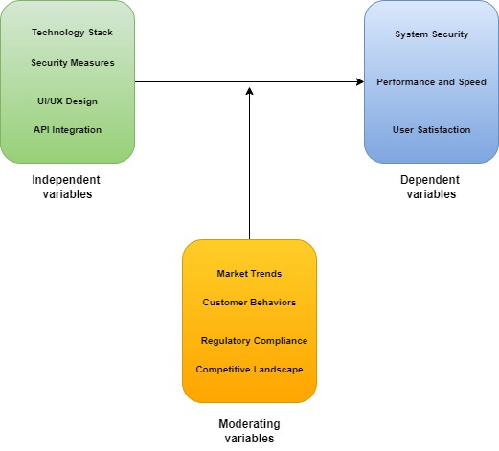

Figure : Conceptual framework

The above-illustrated figure depicts a conceptual framework, which is developed based on key variables, such as independent variables (i.e., Technology stack, Security measures, UI/UX design, and API integration), dependent variables (i.e., System security, Performance & speed, and User satisfaction), and moderating variables (i.e., Market trends, customer behaviors, regulatory compliance, and competitive landscape).

The technology stack can impact the performance and efficiency of the proposed system because an accurate selection of the most suitable programming language and web frameworks can be helpful to easily and efficiently develop any web platform (Cao et al., 2022). The security measures can directly influence the security of the proposed full-stack web application system, as the integration of robust user authentication and encryption measures can be helpful in preventing data breaches. A user-friendly and appealing UI/UX design can largely enhance user satisfaction by enabling the users to easily navigate the diverse web functions. API integration can be helpful in easily and seamlessly integrating the proposed web system with many other third-party systems to ensure continuous functionalities and operations without any interruptions.

# Summary

This chapter provided a critical literature review of the existing and relevant literature on this research topic. This chapter first provided the evolution, growth, and challenges in the e-commerce industry. Then it discussed the factors that impact technological advancements and consumer purchasing behaviors in the e-commerce industry. Then it provided the impact of COVID-19 and the growth of e-commerce platforms during this pandemic. Then it provided a discussion of the core aspects of the development of the proposed app, including frontend & backend technologies, API integration, and database management. Then it provided associated security challenges and best practices or strategies to prevent and mitigate those security issues. Further, it highlighted the key research gaps that have not yet been explored in the existing research studies. Finally, a conceptual framework is developed based on the independent variables, dependent variables, and moderating variables.

# Methodology

This chapter serves as the discussion of the chosen methodology to develop the proposed full-stack e-commerce web application. It forms a solid foundation to systematically conduct and proceed with this research while addressing the specified research questions and objectives. This chapter will discuss the chosen research methodology, strategy, and approach followed by data collection and analysis methods with a discussion of the achievement of superior quality standards and trustworthiness throughout this research. Then the desired tools, techniques, and standards will be discussed for the design and deployment of the proposed system along with the adopted experimental methodology and rationale behind the selection.

## Research Methodology

It represents a systematic process of describing the used procedures and methods for recognizing and analyzing the data or information related to the research topic. Using this, the researchers can design their research to attain the set objectives and answer the research questions (Sreekumar, 2024). It encompasses all the key aspects of the research studies, such as research approach, research strategy, data collection, and data analysis methods.

In this research, **qualitative research methodology** is used to provide a comprehensive understanding of the selected research topic by including an in-depth, broader, and holistic overview of the research questions. Also, this research methodology demonstrates that all of the elements of research work collectively to successfully conduct the research. The addressed research questions in this research can only be answered using the qualitative research methodology (Dianda & Pandin, 2021). There are three major concerns, such as validity, reliability, and generalization related to the selection of qualitative research methodology. During this research, I felt that the integrity and sensitivity might impact this research and reduce its impact.

### Research Approach

The research approach represents a plan or procedure chosen for gathering, analyzing, and interpreting the research data. It is based on a systematic combination of the theoretical framework and empirical findings to conduct a matching process for enabling the researcher to consider novel information, narrowing or expanding the spectrum of this research.

In this research, an **inductive research approach** is used to form new theories based on obtained observations. It starts from the data collection followed by the identification of key patterns necessary in forming new research hypotheses or theories (Masud, 2024). It provided extreme flexibility throughout this research, any necessary changes can be made in this research as per the collected data or information. It can be helpful for businesses to identify the key tactics and considerations to develop and adapt their e-commerce platforms.

### Research Strategy

As this research is conducted using qualitative research methodology, an appropriate selection of the research strategy is necessary for this research. There are many options for the research strategy. An effective understanding of and differences between all these options is necessary to choose the most appropriate and effective research strategy for this research.

In this research, a **design science research** strategy is used to focus on developing a robust technological solution to realize a full-stack e-commerce web application. It is suitable for this research, as this research seeks to resolve a practical problem related to the requirement of a highly dynamic and secure e-commerce platform by enabling the researcher to iteratively design, implement, and refine a robust solution based on empirical feedback and theoretical insights.

### Data Collection

Data collection forms the base for the research, which can be done in multiple ways for the collection of research data. In this research, we used secondary data, which is based on the data from previously published and relevant research studies, such as reports, research articles, and literature (PRIAMBODO et al., 2021). The collected secondary research data provide key insights based on supportive sources by discovering novel dimensions considering the research problem. The secondary data sources are collected from IEEE Xplore, Google Scholar, Springer Link, Science Direct, Government publications, and other sources. These sources provide key insights and information to demonstrate the need and emergence of e-commerce platforms across diverse industries. This data demonstrated the issues, needs, demands, and preferences of the users from the e-commerce platforms that will be restructured for realizing an seamless facilitation of the proposed system.

### Data Analysis

The process of data analysis represents a systematic use of logical or statistical methods for describing, illustrating, condensing, recapping, and evaluating the collected research data. It helps to transform the collected data in raw format to actionable insights for making the most informed decisions throughout the search to better answer the research questions and address the research objectives (Simplilearn, 2024).

In this research, a **content analysis method** can be used that includes analysis of user manuals, technical documentation, and developer logs. This data analysis method can facilitate a systemic assessment of the textual data in recognizing key trends, patterns, and areas that need further examination. Here the collected data need to be coded for identifying key research patterns and themes with a frequency count to further support the identified themes.

## Experimental Methodology

This section depicts the details of the chosen software development methodology along with the employed processes, standards, tools, and techniques to design and deploy the proposed dynamic and secure full-stack e-commerce web platform. Each of the components of the experimental methodology has been carefully chosen while ensuring that they meet high-quality standards to realize a robust e-commerce platform.

### Software Development Methodology

In this project, an **Agile software development methodology** is used which is a robust methodology and highly suitable for this project due to the iterative and dynamic nature of the proposed e-commerce web application. It offers higher flexibility, collaboration, and consumer satisfaction by facilitating a set of key principles while facilitating key functions via an incremental and interactive strategy (Brush & Silverthorne, 2022). This methodology emphasizes the significance of teamwork and collaboration to ultimately deliver a high-quality financial product to better meet the needs, demands, and expectations of the targeted audience.

#### Rationale

The Agile project management methodology is selected due to the complex nature of this research project. The use of this project management methodology offers higher adaptability and flexibility for enabling the developed to embrace potential changes and requirements throughout the projects while enabling the team members to effectively respond the market demands, priorities, and consumer feedback. It emphasizes including the customers throughout the entire project lifecycle to make them feel valuable and ensure that their needs and expectations are met. Further, it significantly promotes an iterative aspect of software development along with the timely delivery of the software product. Moreover, Agile methodology realizes a culture of continuous learning & development and can recognize the potential areas that need improvements while optimizing the processes and addressing the associated challenges.

### Process

The development process for the proposed full-stack e-commerce platform comprises five key phases. These phases are illustrated below.

* **Requirement collection and analysis**: In this phase, all the necessary requirements relayed to the development of the proposed e-commerce website are gathered and analyzed. Here stakeholder meetings were conducted to assess their specific needs and expectations from this web application. Then the project scope is defined, including the key features & functionalities. Further, detailed project specifications and user stories were created.
* **System design**: Then the collected requirements are extracted to gain vital insights for creating the most appropriate design of the system, including low-level design and high-level design. The low-level design is used to better define the behavior and structure of the individual components of the systems, whereas the high-level design defines the overall system architecture.
* **Development**: Based on the developed design and specifications, suitable codes were developed for both the backend and front end of the proposed system using Springboot for backend development and Angular for frontend development (Ali, 2023). API integration is used to link both backend and frontend layers of the system along and MySQL database system is used to securely store and manage the relevant data with the system.
* **Testing**: Then comprehensive testing will be conducted using unit testing, performance testing, integration testing, regression testing, and user experience testing to ensure and validate that the proposed system is well-functional and performs as intended.
* **Deployment**: After testing and validating the functionality of the proposed system, this proposed web application is released to real-time environments its performance is monitored and customer feedback is obtained to make necessary corrections and updations for facilitating ongoing improvements.

### Tools

In this project, several tools are used for the development of the proposed e-commerce web application platform. These tools are discussed below.

* **IDE**: IntelliJ IDE represents the most powerful and popular IDE, which is developed by JetBrains and is mainly used by Java developers for better supporting a comprehensive range of diverse programming languages. In this project, an IntelliJ integrated development environment is used which is written in Java to develop the code in Java programming language. It offers all the basic features in its free version and advanced features in the paid version.
* **Programming language**: Java is one of the most popular and comprehensively used programming languages to develop code for web applications. It represents an object-oriented, multi-platform, and network-centered programming language that could be utilized to develop enterprise-level applications while realizing a highly secured and consistent coding environment. Most of the rules and syntax are based on C and C++ languages.
* **Backend framework**: In this project, a springboot framework is used to develop a backend for the proposed e-commerce website. It is a highly flexible and powerful framework to simplify the overall process of web development through its built-in libraries and default configurations without any additional setup. It also provides RESTful APIs to enhance the system's capabilities in better handling client requests and server responses.
* **Frontend framework**: For frontend development, an Angular framework is used to build highly flexible, responsive, and dynamic single-page applications using its robust tools and techniques to develop single-page applications (Nihar-Raval, 2024). In this project, its latest version Angular 13 was used to develop clear and consistent codes with single routing options. It enabled the developers to divide the system code into distinct files
* **API integration**: In this project, APIs are used to set and hold the overall digital landscape for the proposed system together. It acts as the bridge between the front-end and back-end of the proposed e-commerce web applications to communicate information between both layers. In this project, a no. of APIs are used, such as authentication APIs, product management APIs, order processing APIs, payment gateways APIs, and logistic/shipping APIs.
* **Database**: A MySQL relational database management system is used in this research to efficiently support various database operations and secure data management. It helped in efficiently storing and handling the vast amount of data related to e-commerce platforms, such as customer’s personal data, product data, payment details, and logistic information.

### Standards

The software development standards offer a set of potential best practices and guidelines to develop a robust software system. This research project adhered to several robust industry standards for ensuring an exceptional level of performance, quality measures, and security measures of the proposed e-commerce platform. These standards realize a mutual approach for an efficient software development process in a highly reliable and consistent manner.

* **Design standards**: The design standards are helpful for the developers in guiding them to develop effective designs for the developing software system. These standards provide a well-structured strategy to solve key design issues related to the implementation by allowing the developers to develop highly flexible, scalable, and easily maintainable code (Dhiman, 2023). This research used Singleton and Model-View-Controller (MVC) design patterns for creating effectual designs for the proposed application. The MVC structure is used in separating the data related to application and user interface logic into separate components, whereas the Singleton pattern was used to ensure that each class comprises only a single instance with global access.
* **Coding standards**: For easy readability and long-term success of any software project, an easily maintainable and consistent code is important. This project uses Java programming language to develop the necessary code for the proposed software application. Thus, the developers need to adhere to all the coding conventions along with the rules & regulations applicable in Java to write clear, consistent, and readable code. This coding standard guides the developers in using appropriate naming conventions, error handling, code structure, code review, and documentation.
* **Testing standards**: The testing standards are essential to ensure that the development website must meet the end-user's needs (OpsLevel, 2024). The International Software Testing Qualification Board (ISTQB) mainly focuses on fostering the testing process. The ISTQB standard offers a robust approach to testing and ensuring consistent quality throughout the entire software development lifecycle. It guides the developers in developing a robust test plan, creating the most effective test cases, and selecting suitable testing methods to test the effectiveness of the proposed system and ensure it functions as intended.
* **Security standards**: Security is the most significant consideration in the development of the proposed e-commerce web application system. Thus, this project needs to adhere to the open web application security project to ensure that all the possible associated vulnerabilities are well-addressed. The developers followed the practices and guidelines of OWASP for securing the proposed application from the general security issues and threats (Victor, 2023). Further, it provided a solid base for testing this web application based on the technical security controls against the security vulnerabilities to ultimately realize a highly secure web development process.

### Techniques

This research project used serval key techniques, such as database normalization, secure coding practices, test-driven development, and continual integration or continual development.

* **Secure coding practices**: Secure coding practices are important to securely write code for the development of software applications. It is very necessary in the software development process because it helps to identify and address any security issues during the development phase because it is very expensive to resolve any issue after the development. This project used input validation to prevent any malicious data from being processed by the proposed system that might cause security vulnerabilities, output encoding to prevent the cross-site scripting attack by properly encoding the available web content, and secure user authentication schemes for protecting the proposed system from any unauthorized access. A proper error-handling mechanism is followed to ensure that any confidential information is not disclosed to any user.
* **Database normalization**: A systematic normalization method is used to efficiently store and organize the data present in an SQL database. It is used to store the data into tables while establishing relationships between the tables as per the designed rules for protecting the stored data and making the database more flexible while eliminating the inconsistencies and redundancies (S, 2024). It is used by the developers to store the details of the made orders by the customers in separate tables.
* **Test-driven development**: The test-driven development method is new emerged software development approach that mainly focuses on the creation of unit test cases before the actual code development of the developing software system. It represents an iterative method that combines programming language, creation of unit test cases, and refactoring [(Unadkat, 2024)](https://www.browserstack.com/guide/what-is-test-driven-development) . In this project, the developers used this approach to develop the important features of the proposed application, such as adding items to the cart, updating or deleting items from the cart, and proceeding to the checkout process. The relevant test cases are developed for validating these test cases and then necessary codes are developed for implementation to ensure that these test cases are met.
* **Continuous Integration/Continuous Deployment (CI/CD)**: CI/CD represents a set of key processes or practices for enabling the team members to frequently and consistently deliver the changes in developed code. The developer team implemented smaller changes in the code using continuous integration and then checked it into the version control repository. It helped in establishing automotive ways of building, packaging, and testing the developing software applications. After continuous integration, continuous delivery takes place by automating the process of delivering software applications into the chosen software atmosphere, such as production, testing, and development environments. Continuous delivery helps in easily pushing the made changes to code into these environments.

# Summary

This chapter provided a detailed discussion of the chosen research methodology and experimental methodology. Then a qualitative research methodology is selected along with the inductive research approach and design science research strategy to better conduct and proceed with this research. Further, the following data collection process is discussed in which the sources from where the data is collected are discussed. Then the content analysis method is discussed that is used to analyze collected research data. Then the chosen experimental methodology, including Agile project management methodology, development process, tools, standards, and techniques was discussed in detail.

# Requirements and Design

This chapter is based on the discussion and design of the proposed full-stack e-commerce website platform. It will realize groundwork for realizing an effective procedure for software development based on a systematic identification of key project requirements and robust design to guide the developers in developing necessary codes and deploying the proposed application in real-world scenarios. This chapter will first provide the functional & non-functional requirements for the proposed application based on technological considerations, market trends, and evolving user needs (Haryanti & Pribadi, 2019). It will critically explore the key project requirements based on the use cases and user stories following the architectural design of the proposed system, including both low-level and high-level designs and employed design patterns.

## Requirements

The project requirements represent a set of key specifications that describe the user interactions and behaviors of the proposed e-commerce website. These requirements represent key functionalities and abilities that are needed in the finalized product. This developed e-commerce website comprises two major requirements, namely functional requirements and non-functional requirements. The functional requirements demonstrate the technical functionalities of the developed website to address how this website needs to function, whereas the non-functional requirements demonstrate how the developed website is supposed to perform a specific function.

### Functional Requirements

The functional requirements represent the interaction and behaviors of the proposed website, which can be based on the business and customer needs (Ceymox, 2021). The key functional requirements for the proposed e-commerce website comprise third-party integration, product attributes, mobile responsiveness, order & checkout flow, and social sharing.

#### User Stories and Use Cases

##### User stories

* The visitor wants to create a new user account on the website using their personal details and the registered users want to log into the e-commerce system.
* The customer wants to browse the available product categories on the website using the keywords and apply filters to get a refined list of products.
* The customer wants to add the desired products to the cart and update or remove the items from the cart.
* The customer wants to proceed to the checkout page and select a suitable payment method to place the order (Holsing & Schultz, 2016).
* The customer wants to check the order history, track the past orders, track the status of the current orders, and request an exchange or return any delivered item.
* The admin wants to add new products to the product catalog, update product details, and remove older or outdated products.
* The admin wants to review and manage the customer orders, update the order status, and handle all the requests of the customers.
* The customer wants to access consumer support services via call or chat, access the FAQ section, and provide feedback about their experience with this website.

##### Use cases

Table : Usecases of the proposed application

|  |  |  |  |  |  |
| --- | --- | --- | --- | --- | --- |
| **Use case ID** | **Name** | **Actors** | **Precondition** | **Success scenario** | **Postcondition** |
| UC 01 | User Registration | Visitors | The visitor is redirected to the registration page. | Visitors register using personal details and the system sends confirmation mail for registration. | A user account is created and the user is redirected toward the website’s login page. |
| UC 02 | Product search and filtering | Customers | The customers browse the product catalog page of the website. | Customers input keywords in the search bar and the system displays matching products and can apply filters to further refine the displayed products (Harris et al., 2016). | The customers get a refined list of the matching products. |
| UC 03 | Checkout procedure | Customers | The customer has a list of added items in the cart. | The customers review the cart and proceed to checkout, enter shipping details, choose a payment option, and place an order. Then the system confirms offers and sends a confirmation email. | Order is placed and the customer receives a confirmation email with the expected delivery date. |
| UC 04 | Product management | Admin | The admin needs to log in to its dashboard. | Admin adds a new product, enters relevant details, uploads images of products, and lists on the product catalog. | The newly added product is displayed on the website’s product catalog. |
| UC 05 | Order tracking | Customer | An order has been placed by the customer. | The customers log in to their account, navigate to the order page, and choose an order to check the status, and the system displays the order’s current status. | The customers get an updated status of their orders. |

### Non-Functional Requirements

The non-functional requirements are responsible for demonstrating the performance of the developed website and the positive user experience with this website. These requirements could be developed, modified, and adapted following the needs of businesses and customers. Generally, these requirements are categorized into revisional, operational, and transitional categories. These requirements help in controlling product quality and user expectations (Mickiewicz, 2020). The non-functional requirements include performance, usability, scalability, security, and maintainability.

### Minimum Viable Product (MVP)

The minimum viable product represents an initial version of any product with just basic features that can be used by early-stage customers and gather their feedback for improving further product development process. In this research, MVP is used to deliver all the essential features of the proposed e-commerce website including all the core needs and expectations of targeted customers (Suscheck, 2024). Based on the MVP, further improvements and features are presented to improve the overall scalability, functionality, and user experience.

Table : MVP and it's features

|  |  |
| --- | --- |
| **MVP** | **Features** |
| Basic e-commerce platform | * The visitors can securely create user accounts and log in to the website. * The users can browse the product catalog by categories and apply filters. * They can add, review, and update the items in the cart. * They can simply redirect to the checkout process and place an order. * They can access past order histories and track the status of current orders. |
| Improved user experience | * The users can apply filters on the products by price, categories, and ratings (Lenarduzzi & Taibi, 2016). * The users can make updates to their user profile. * Admin can update the status of the customer’s orders and raise exchange or return requests. |
| Performance optimization and security improvements | * Caching mechanisms were implemented to decrease load on servers, augment the database indexing & queries, and let users rate the products. * Periodic security checks are conducted and robust input validations are implemented to ensure system integrity. |
| Scalability | * The developed e-commerce website deployed on scalable cloud platforms like Azure or AWS. * The website is integrated with the global logistics service providers to support widespread shipping. |

### Requirements by Increment

After introducing MVP for the proposed e-commerce system, this section provides some additional features and improvements in the form of increments. Each of these increments develops based on the existing version and focuses on adding key values to the proposed application.

* **Increment 1: Improver customer service experience**

The project can focus on further optimizing the features and functionalities of the proposed e-commerce website. Advanced filtering options, such as brand, price range, color, user ratings or reviews, etc. The website needs to recommend relevant products to the customers based on their purchasing history and behavior (Adeola et al., 2020). The saved items and wishlist features should be added along with a guest user functionality. Further, it must support all the popular and most frequently used payment options.

* **Increment 2: Optimized web performance and security**

The project should deploy caching mechanisms for optimizing the response time of the system and database indexing & queries. Further, regular security audits should be conducted, and two-factor authentications to enhance the security of the system.

* **Increment 3: Advanced inventory and order management**

The project can add real-time tracking functionality to the proposed website with a seamless integration of logistics services. Further, real-time tracking of inventory should be added with an automated notification about restocking.

## Design

### Low-level Design

The below-illustrated diagram depicts the low-level design for the proposed e-commerce system. It depicts all the key elements of the proposed system. It illustrates that both web clients and mobile clients can use this website and request to explore the website for the desired products. The requests of both clients are redirected to the load balancer that distributes website traffic across multiple servers of the website. They enhance the website response time and performance by decreasing the network latency and loading time (Gaikwad, 2023). The users can access the available services on the backend, such as account management service, search service, product services, cart service, checkout service, payment service, and security service. All the backend services carry some data related to the offered services that are stored in the attached database. A cache is attached that helps in retrieving the recently read data. A file system is also there to manage the stored files in the MySQL database.

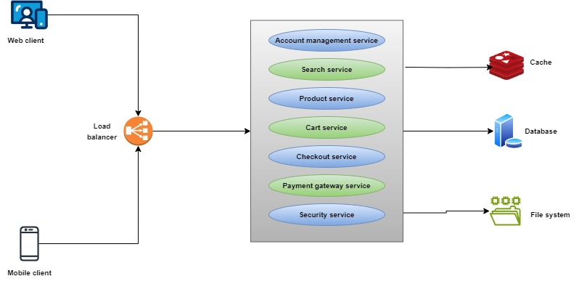

Figure : Low-level design

This project has employed an MVC (model view controller) design pattern with microservices for better structuring and linking both of the front and backend of the proposed system and realizing seamless communication between them. A singleton pattern is also utilized for the Springboot framework to ensure well-controlled resource access while reducing memory usage and maintaining consistency across the proposed application (Gaikwad, 2023). Further, a repository pattern was employed to better manage access to data to handle and manage different data sources. It helped in separating the business logic from the data access logic to clean the codebase and realize easy testing of the build business logic.

### High-level Design

The below-illustrated diagram depicts a high-level diagram for the proposed e-commerce system. According to this diagram, a user can interact with the user interface of the system. A content delivery network is used, which provides static data to the user and takes cached data from the web application. This user interface sends user requests to the API gateway that links the application’s backend and frontend. This API gateway routes the user requests to the load balancer that distributes the user traffic across multiple servers of the application while reducing the website loading time and latency. There are several services, such as product service, user service, order service, inventory service, and payment service available at the backend of the system that can be used by the users. The users can access the user service to update and manage their on this website. The user can search for the desired products by entering the relevant keywords (Wong, 2024). Then the product fetches data from the cache to provide the most relevant and accurate results. After the selection of desired products, the user can add those items to the shopping cart and proceed to the checkout process. Then the user can raise requests to place an order, the order service raise a query to the inventory service to check the availability of the desired product. After checking the availability, the user is redirected to the payment service page, where a payment gateway is attached. Through this payment gateway payment service processes payment and the payment gateway validates the payment with the bank after validating the payment is confirmed and order is successfully made and the user is notified about the order confirmation.

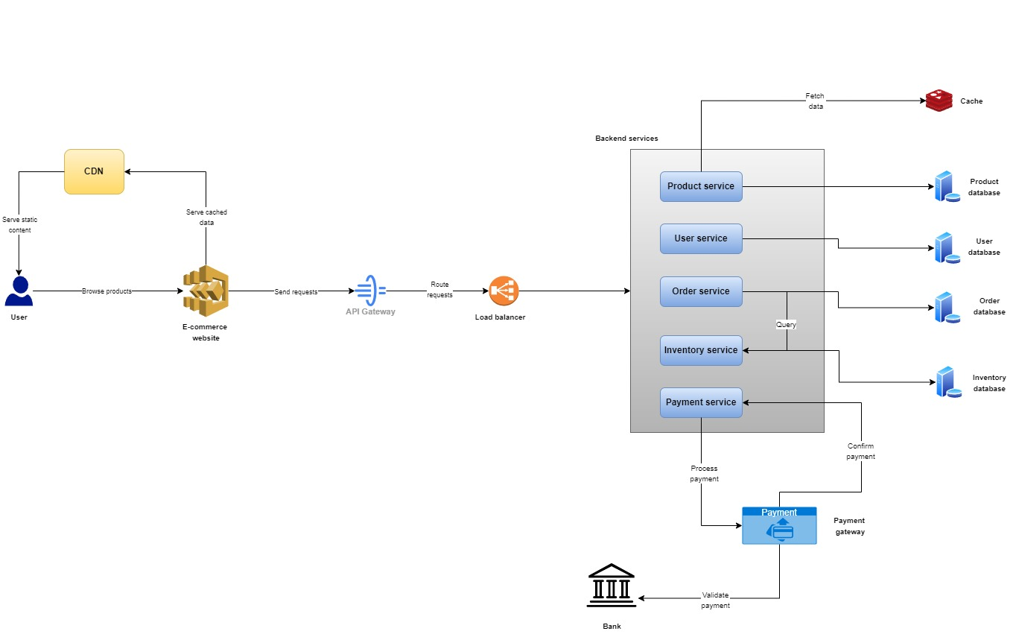

Figure : High-level design

# Solution Implementation and Deployment

This section is based on the discussion of the detailed implementation and deployment process for the proposed full-stack e-commerce website system. Here the used hardware, networks, storage, and software systems, tools, or techniques will be discussed that all work together in transforming the gathered project requirements and design specifications into a highly functional and scalable system that can be used by targeted customers. This section mainly intends to position the developing software system into real-time scenarios while ensuring that it meets the user's needs and demands.

## Hardware

This section outlines all the necessary virtual and physical infrastructure for effectively deploying and running the proposed e-commerce website with a prime focus on Agile, DevOps, and Cloud Computing platforms. This project used Amazon Web Service (AWS) to realize the flexibility of scaling the resources as per requirements and minimizing the associated overheads.

* **AWS S3 (Simple Storage Service)**: It represents an object-oriented storage system that provides industry-leading data availability, performance, and security. In this project, it was used in optimizing, configuring, and organizing the data while meeting the compliance and organizational requirements.
* **AWS EC2 (Elastic Compute Cloud)**: It is a web-based service that was used in this project to run the developed e-commerce website over the AWS cloud platform (Awati & Carty, 2024). It provided a highly secure and scalable computing capacity to better run different types of workloads.
* **AWS RDS (Relational Database Service)**: It is another service of the AWS public cloud. This project helps in setting up and operating the MySQL relational database to better store and organize the relevant data.

### Local Development Setup

This project used the below-illustrated setup for the progression, testing, and restoring processes.

* **Development servers**
* **Processor**: Intel Core-i5 3350P Quad-Core Processor
* **Storage**: 500 GB SSD
* **RAM**: 16 GB or more
* **Virtualization**: VMware or VirtualBox local virtual machines
* **Developer servers**
* **Processor**: Intel 8th Gen Core i5-8400 Processor
* **Storage**: 256 GB SSD or higher to perform read/write operations faster
* **RAM**: 8GB or more
* **Operating system**: Linux, Windows 10, or macOS

### Hardware for Deployment

This project also needs some more hardware for the on-premise deployment of the proposed system.

* **Application server**: The application server represents platform middleware, which exists among the operating system, user application, and external resources (i.e., internet services, communication systems, and database management systems) (Kanade, 2023). This server was used in this project for executing the necessary scripts and programs using Java programming language to ultimately create a highly dynamic and functional e-commerce website.
* **Load balancers**: This project also used load balancers that work as the single contact points for the customers. It helps in distributing all the incoming user traffic across several targets present in diverse availability zones. In this project, a load balancer was used in sending requestion to browse the available products to the server, containing videos or images of the products.
* **Backup and Recovery Hardware**: A network-attached storage is a backup server that comprises several storage drivers for enabling users to collaborate and share data (Mazor, 2022). It is used in this project for taking backups recovering the unstructured data files and seamlessly sharing data into physical or external drives.

## Networks

### Network Topology

The network topology represents a logical and physical arrangement of the connections and nodes within the system network. The nodes comprise routers, switches, and software to arrange and control the data flow throughout the proposed e-commerce system (Gillis & Nolle, 2021). The proposed e-commerce application is intended to be run over the cloud platforms so this fundamental networking hardware to manage the local environments for the deployment of the proposed e-commerce system. In this project, routers, switches, and firewalls were used to pass and manage data. This project used a hybrid topology, comprising ring, star, and bus topologies with a virtual private cloud (VPC) to better control the overall functioning and functionality of the system.

### Cloud-Hosted Server Topology

This project uses the **AWS EC2 auto-scaling strategy** to ensure that sufficient EC2 instances are available for efficiently handling the increased user traffic and load on this proposed application (AWS, 2024). Further, an **AWS CloudFront** content delivery networking service is used to enhance the performance and security of the developing website while offering convenience to the developers throughout the development process.

## Storage

This research project used the MySQL relational database system to securely store and retrieve the data related to both users and the system.

### Entity Relationship Diagram

An entity relationship diagram (ERD) represents a depiction to demonstrate the relationship among diverse entities related to this proposed e-commerce web platform. It is considered the structural schema of the used database and acts as the framework to define the relationship among entities (S, 2024). It is developed based on the three major components, namely entities, relationships, and attributes.

The below-illustrated figure depicts the entity relationship diagram for the proposed system, which presents a database schema for the chosen MySQL database. It consists of 9 entities, namely admin, customer, product, log-in, register, order, category, payment, and cart. These all entities have their individual attributes that contain certain data, which is stored in MySQL database. All these entities have a primary key, which is unique for each entity. They also carry foreign that help to link two tables in the MySQL database.

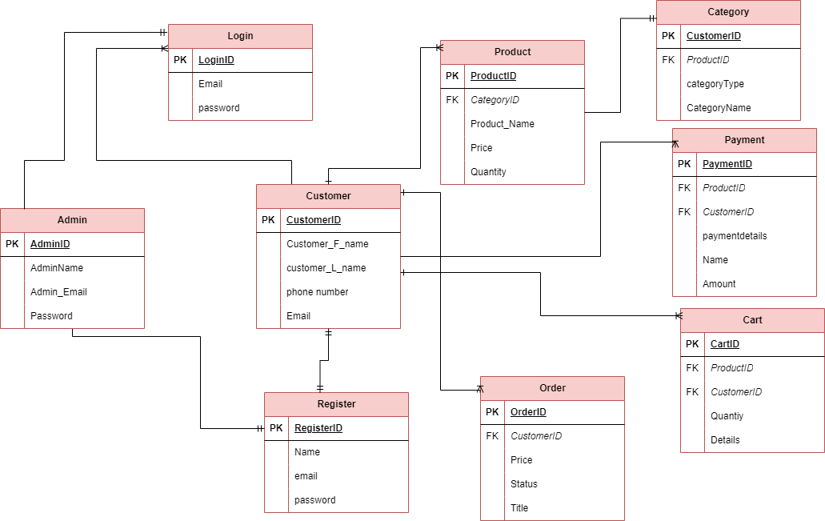

Figure : Entity relationship diagram

#### Relationships between Entities

* The customer entity has a **one-to-many** relationship with the order entity; as a customer can place multiple orders, but an order can only be placed by a customer.
* The product entity has a **many-to-many** relationship with the cart entity; as one product can be added to several carts and each cart can add many products.
* The customer entity shares a **one-to-many** relationship with the payment entity; as one customer can initiate multiple payments but one payment can only be initiated by a customer (GeeksforGeeks, 2024).
* The order entity has a **one-to-many** relationship with the product entity; as one order can contain multiple orders but one product cannot be ordered using multiple orders.
* The order entity has a **one-to-one** relationship with the payment entity; as one order has one payment and one payment can be initiated for one order only.
* Product entity has a **many-to-one** relationship with the category entity; as many products can belong to one category but multiple categories cannot belong to one product.

## Software

### Programming Language

In this research, Java programming language was used, which is an object-oriented programming language. It is a platform-independent programming language primarily used to develop enterprise websites or applications. Its syntax and rules are based on the C & C++ programming languages. This programming language has an easy syntax and it is highly secure, robust, faster, and powerful. It offers immense support from the community along with clear structural programs to reduce development costs. Further, it lets the developers better utilize the Springboot framework in the development of the backend for the proposed system.

### Class Diagram

Class diagram plays a crucial role in the design phase of the overall development of design for the proposed e-commerce website. This class diagram depicts an object-oriented system architecture. It encompasses several classes, such as Customer, product, login, register, cart, order, admin, and payment. Each of the classes is well-defined with the relevant methods and attributes (Edrawmax, 2023). The below-illustrated diagrams depict the compositions, associations, and aggregations among all of the represented classes. This class diagram can serve as the blueprint for the developers to better understand the data structure of the proposed e-commerce system and guide them throughout the development process.

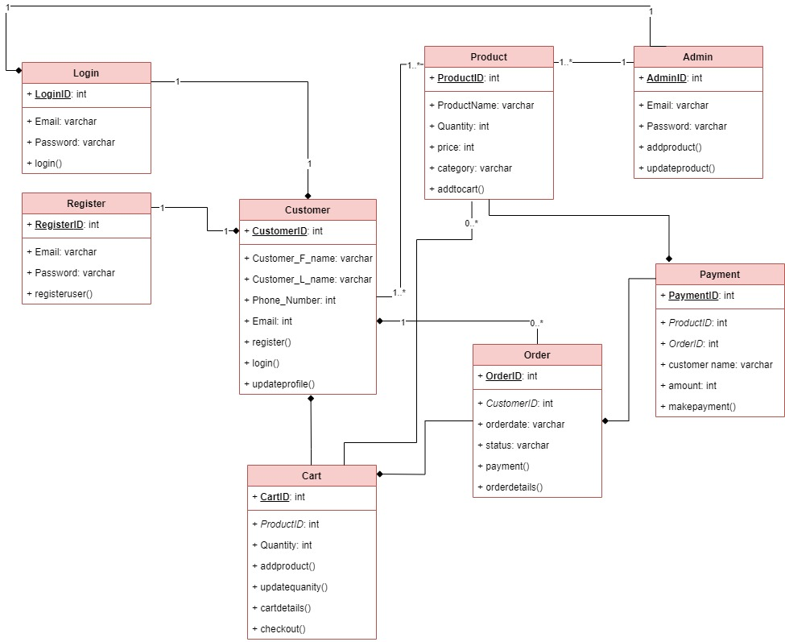

Figure : CLass diagram

### Object Sequence Diagrams

The sequence diagrams are generally used by the developers in modeling the interactions and communication among the relevant objects with the system within a single use case. They represent how diverse system parts interact with each other to carry out a specific function following an order that occurred after the execution of a specific use case (Athuraliya, 2022).

An object represents a sequence diagram that has been drawn as the rectangle comprising the object’s name. The objects can be presented in three different ways, first object name, second object name & class name, and third class name. The objects have the responsibility to manage and mode data across the system along with responding to inquiries and protecting the overall system.

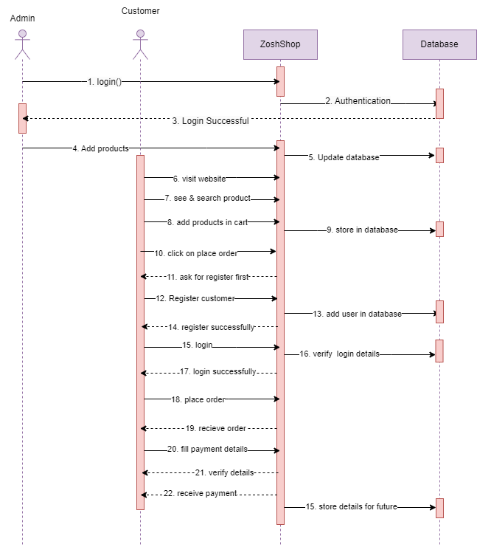

Figure : Object sequence diagram

In this project, two main objects are there, namely customer and admin. These objects can interact or communicate with each other. The synchronous message is typically represented by a solid line with the filled arrowhead. The return message uses a dashed line with the open arrowhead. An asynchronous message represents a solid line with the open arrowhead, it does not have any reply.

### System Development

#### Backend Development

The below-illustrated figure depicts the e-commerce application class. It depicts the details of the imported SpringApplication and autoconfigure.SpringBootApplication. Further, it also depicts other imported things like ExternalDocumentation, OpenAPIDefinition, info.Contact, and info.License. It offers a set of the desired functionalities and endpoints for programmatically integrating with the proposed e-commerce website and using the illustrated API, one can create integrations, and applications, and automate several tasks.

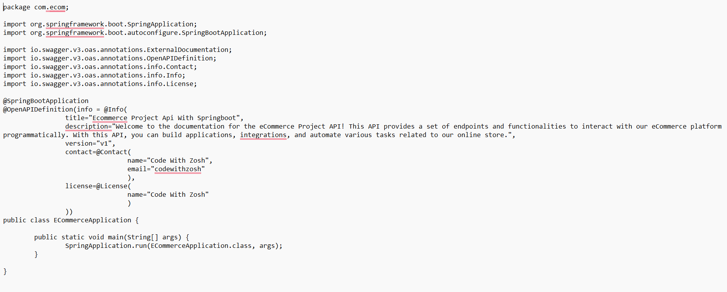

Figure : E-commerce application class

The below illustrated figure addresses that in Cart Controller class, several packages, such as http.HttpStatus, http.ResponseEntity, web.bind.annotation.GetMapping, web.bind.annotation.PutMapping, web.bind.annotation.RequestBody, web.bind.annotation.RequestHeader, web.bind.annotation. web.bind.annotation.RequestMapping, web.bind.annotation.RestController, com.ecom.exception.ProductException, com.ecom.exception.UserException, com.ecom.modal.Cart, com.ecom.modal.CartItem, com.ecom.modal.User, com.ecom.request.AddItemRequest, com.ecom.response.ApiResponse, com.ecom.service.CartService, and com.ecom.service.UserService.

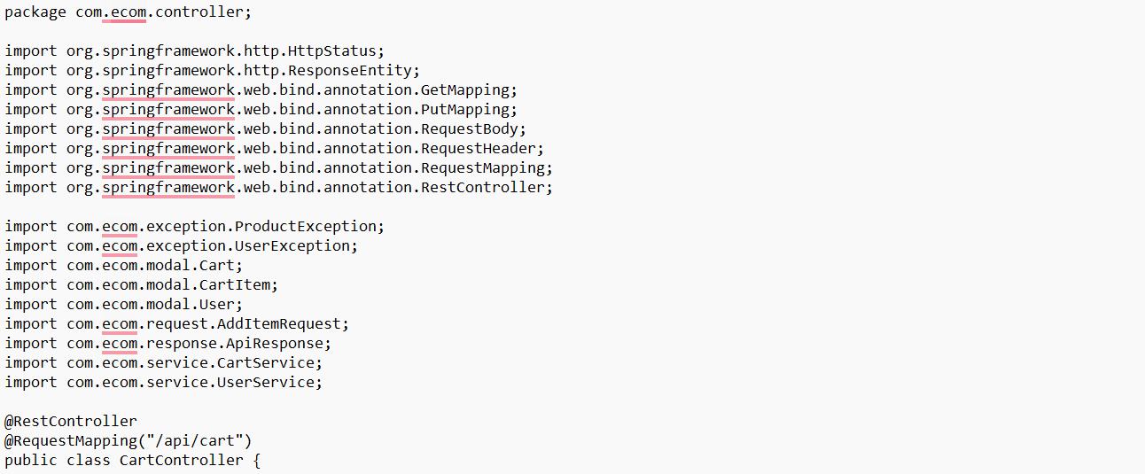

Figure : Imported packages for cart controller

The below-illustrated figure depicts the details of the cart control class. It illustrates the use of @GetMapping("/") and @PutMapping("/add") annotations which are used in Springboot for mapping the HTTP Get requests on specific handler methods.

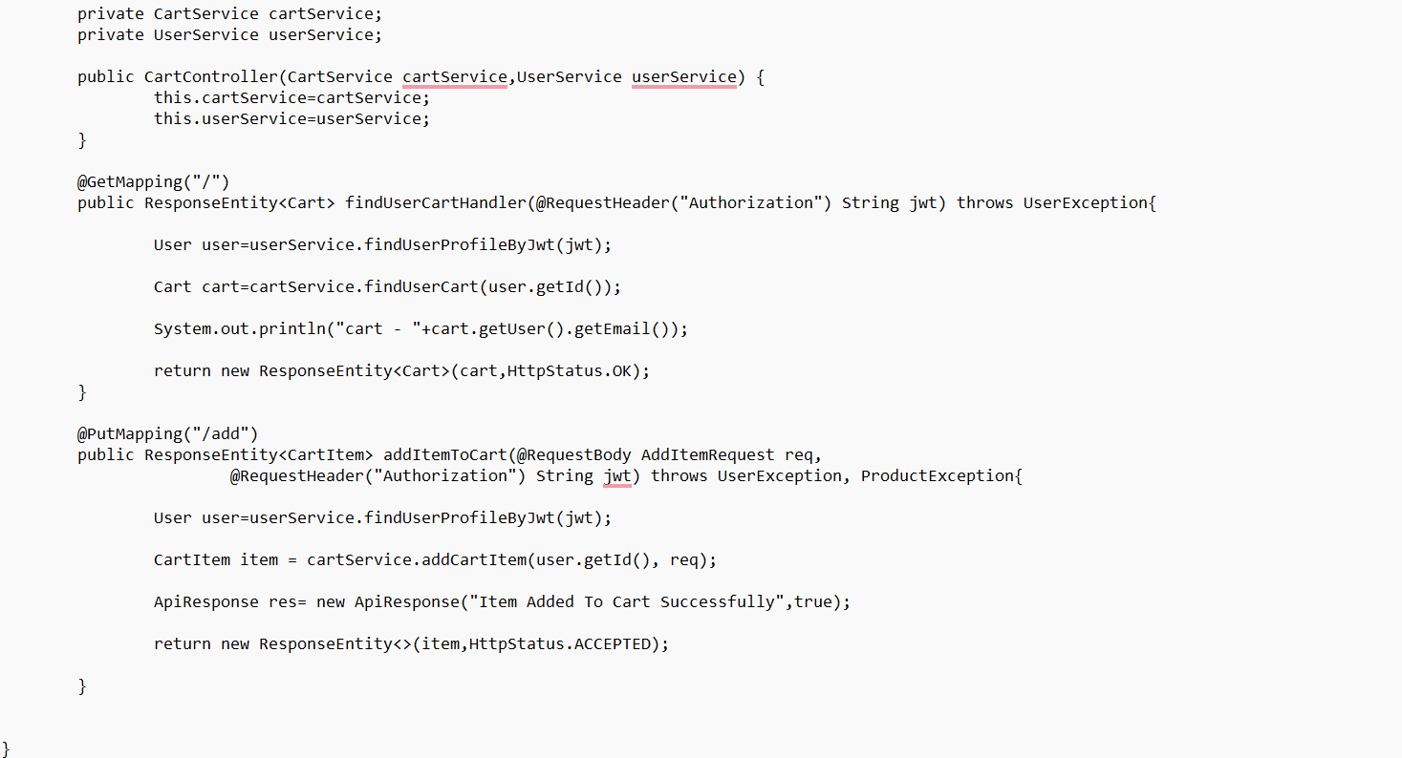

Figure : Cart controller class

#### Frontend development



Figure : Home page

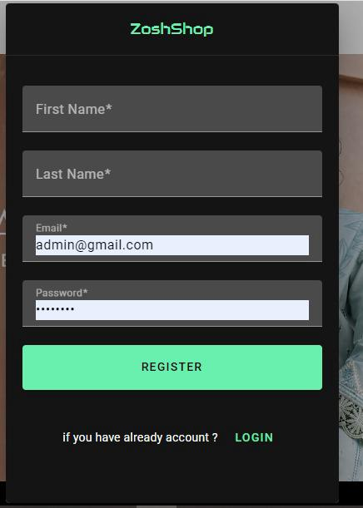

Figure : Registration page

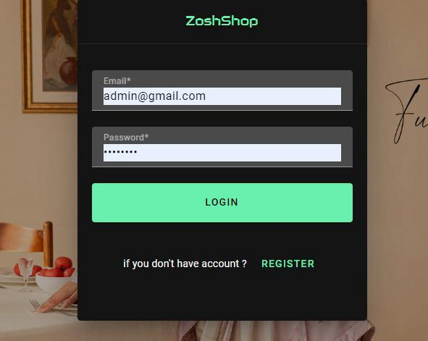

Figure : Login-page



Figure : Product page (men's kurta)



Figure : Product page (women's gowns)

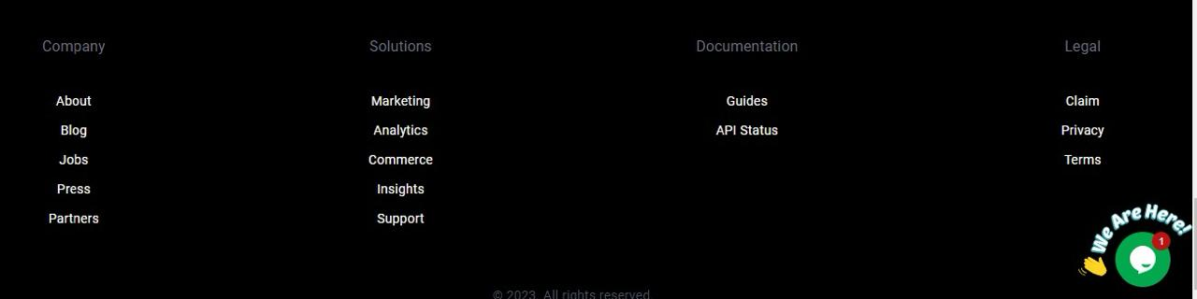

Figure :Footer of the website

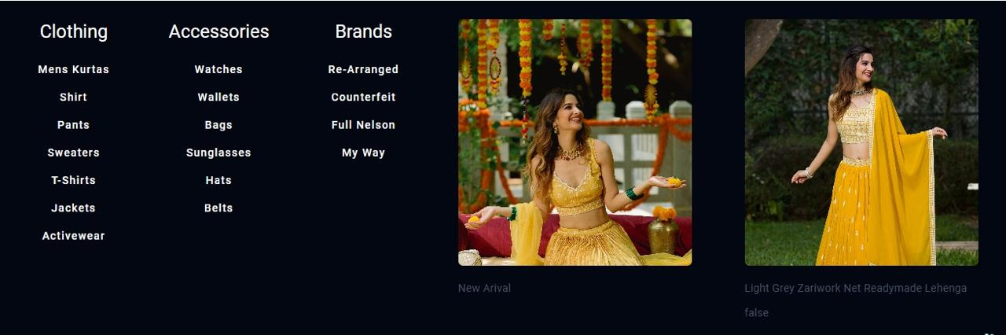

Figure : Category Page

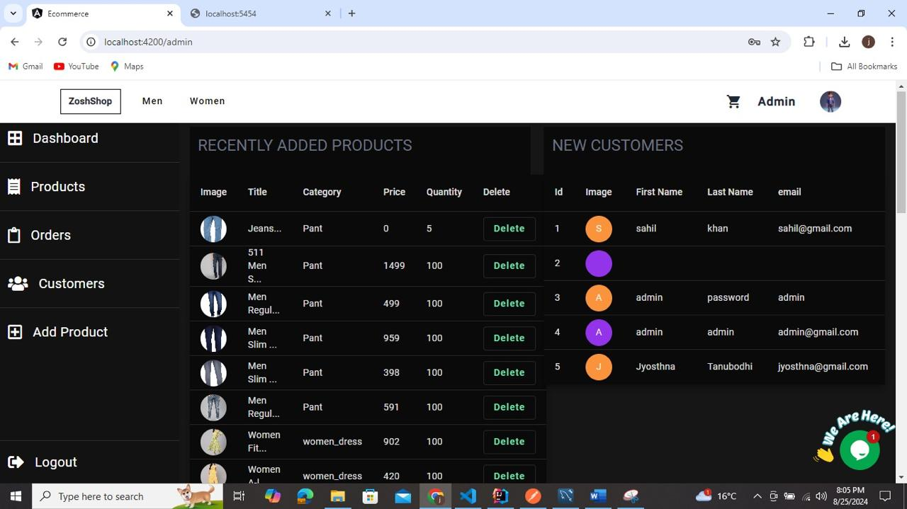

Figure : Admin Dashboard

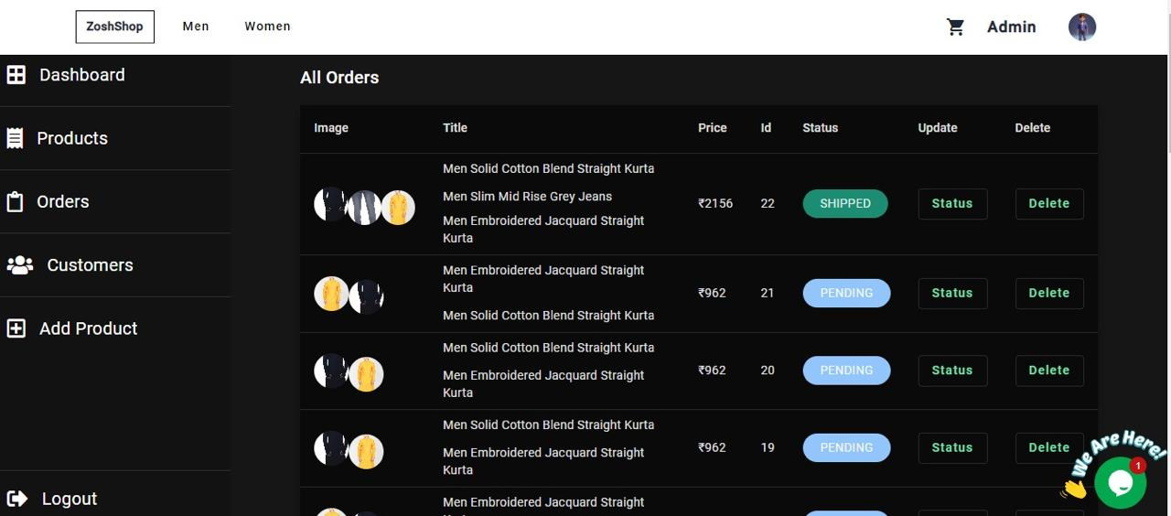

Figure : Order history page

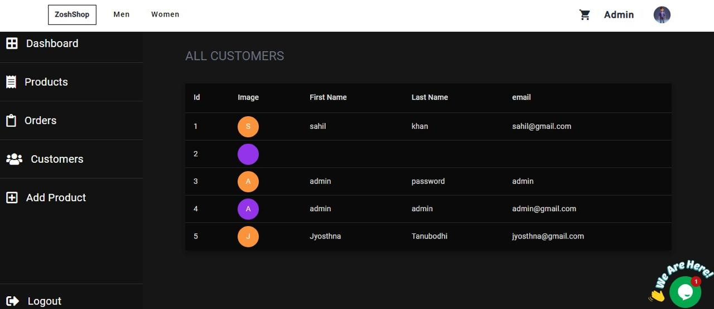

Figure : All Customers

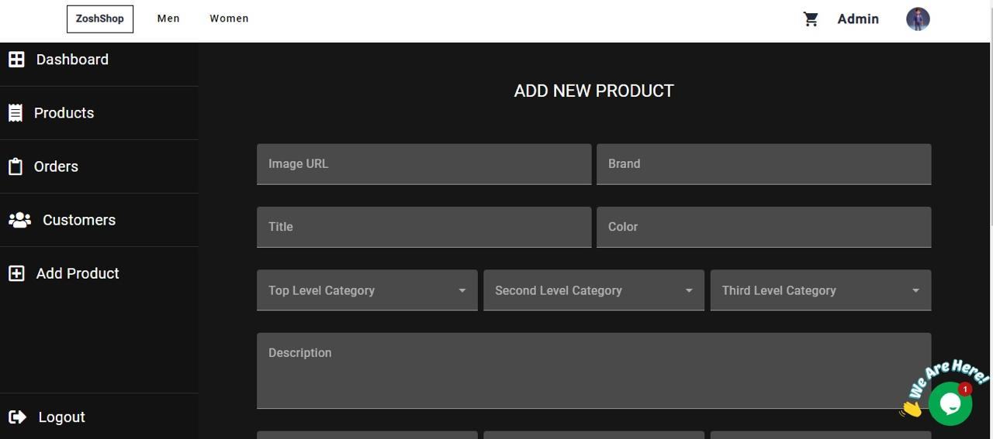

Figure : Add new product page

# Solution Evaluation

This section mainly focuses on evaluating the proposed full-stack e-commerce website to enhance the user experience during online shopping. It will use unit testing and end-to-end testing methods to test the effectiveness of the developed e-commerce website. Then it will present the most relevant test cases for authorizing this website along with the obtained test results from the conducted testing.

## Test Plan

A test plan represents a comprehensive document outlining the key strategies, objectives, timelines, goals, and resource requirements for the completion of any software system. It depicts all the testing-relevant activities and can comprise diverse project levels to test the used processes and developed software products. It can be developed by the project managers to validate the effectiveness and functionalities of the tested software system.

### Unit Testing

This is the primary testing that mainly focuses on testing the individual components or modules of the system for validating the quality of the developed code. It is performed by the developers during the coding phase. It helps in segregating diverse logical parts of any software system and correctly testing their individual behaviors. In this project, this testing is conducted manually.

### End-to-end Testing

End-to-end testing represents a testing method to test and validate the functionality of the whole application from beginning to end. It emulates the generally performed tests and user actions considering the project outcomes (Gillis, 2023). It is performed after the unit and integration tests. The developers tested the technical functionalities as well as the user interface of the proposed system using this testing method.

## Test cases

The test cases represent the required actions for validating the key functionalities and features in the software testing. These test cases comprise data, steps, preconditions, and postconditions required for validating a specific feature and functionality.

|  |  |  |  |  |
| --- | --- | --- | --- | --- |
| **Test case ID** | **Name** | **Objectives** | **Input** | **Expected outcomes** |
| TC 01 | Validating user registration | It aims to ensure that users provide correct input during registration. | Username, email, contact number, and password | Validation was successful and users get a confirmation email for registration. |
| TC 02 | Adding item to shopping cart | It aims to validate that the items are successfully added to the shopping cart. | Item ID and quantity | The selected items are successfully added to the cart and total counts are updated. |
| TC 03 | Calculating the total price from the cart | It aims to ensure that the total price of added items to the cart is correct. | Item price and quantity | The total price of added items to the shopping cart is correctly updated. |
| TC 04 | Validating user login credentials | It intends to ensure that the user’s login credentials are correctly validated. | Username and password | The credentials are validated and users successfully log in to the system. |
| TC 05 | Validating product search functionality | It intends to verify that the search functionality works correctly and displays correct results. | Search query | The search results displayed correct and relevant products. |
| TC 06 | Integrating payment gateway | It aims to verify that all the payment options are successfully integrated with the system. | Item, quantity, and payment detail | All the payment options worked smoothly and payment was successfully done. |
| TC 07 | Testing the security measures | It mainly aims to authenticate that this system prevents security attacks and protects user’s sensitive data. | Customer data, payment details | The security measures are effective and all the sensitive data was protected well. |

## Test Results

The test results demonstrate the obtained actual outcomes from the connected testing and test cases for the developing software system. The test results should be carefully monitored and documented in a comprehensive report with their status to address whether the conducted test case failed or passed. These test results depict key insights related to the project deliverables while providing the ongoing status of the project with the involved stakeholders.

* **Unit test results**

This testing method provided critical testing of all the individual components of the proposed system. All the relevant test cases were successfully passed. It demonstrated that the users are successfully registered, desired items are added to the shopping cart, Login credentials are validated, search functionality is validated, smooth payment processes are realized, and attached security measures are efficient [(Unadkat, 2024)](https://www.browserstack.com/guide/what-is-test-driven-development).

* **End-to-end test results**

It is used to test the functionality of the overall system. It demonstrated that the users were successfully registered and logged in to the system, redirected to the checkout process, managed their user profile, submitted product reviews & ratings, tracked the order status & history, had robust security features, performed well under higher user traffic, session management, and logout functionalities worked well.

The overall test results addressed that the proposed e-commerce system is ready for deployment in real-world scenarios. However, some minor changes or improvements can be made to further optimize its robustness and performance.

# Critical Evaluation

This section focuses on providing a critical evaluation of this project, which is focused on developing an efficient and scalable full-stack e-commerce website to enhance the customer’s experience during online shopping by further improving their convenience and ease of use. This section will evaluate the developed e-commerce website against all the specified objectives to validate how it will attain those objective. The used plans and provided explanations will be critically reviewed to identify any deviations. Finally, a reflection will be provided to address the learned lessons during this project.

## Evaluation against Objectives

### Developing a robust e-commerce web platform

The proposed e-commerce platforms in existing research studies were not compatible with all types of devices posing difficulties for the users in accessing the website from preferred devices. Thus, this project has successfully met the objective of developing an efficient and scalable e-commerce website for delivering a unified customer service experience and convenience across multiple types of devices. This proposed e-commerce website has been tested well using all types of devices, such as smartphones, desktops, and tablets that can be used by customers. This testing demonstrated that the proposed system has an extremely responsive and intuitive user interface that ultimately validated that the developed e-commerce website is compatible with multiple devices and the customers reported that they are satisfied with the loading speed and ease of navigation of this e-commerce website.

### Employing advanced technologies

The existing research recommended Node.js and PHP-based solutions for the development of e-commerce platforms. Although these technologies provided robust platforms they did not meet and cope with the currently evolving market and consumer demands (Cao et al., 2022). In this project, a combination of all the latest and advanced technologies is used. It used Java programming language along with the Spring Boot framework for the development of the backend of the proposed e-commerce website. An angular framework was used for the front-end development of this website. Further, a MySQL database was used to securely store and retrieve the relevant data with this system. The combination of these advanced technologies significantly enhanced the scalability and robustness of the developed website by realizing a solid platform for the overall development process.

### Assessing the existing e-commerce technologies

The existing research studies did not fully consider and cope with the latest market trends and consumer demands related to e-commerce platforms. Thus, this research conducted a critical analysis and evaluation of the existing technologies used in the development of e-commerce platforms to gain a better understanding of the gaps, current trends, customer needs, and market demands. This project considered all these things throughout the development of the proposed e-commerce website and aligned the development process and features of the proposed website as per these market trends and consumer needs and demands to realize a highly competitive and resilient e-commerce website.

### Analyzing multiple payment options

The existing research did not emphasize the e-commerce feature of personalized payment options as per geographic locations and customer preference (Cruz-Cárdenas et al., 2021). This developed e-commerce website is designed in a manner to support a range of preferred payment options by the target audience. These features of diverse payment methods were very helpful for the customers to meet their specific needs related to making payments. The conducted testing demonstrated that all the integrated payment options work smoothly and all the payment transactions are made efficiently and securely. It largely contributed to enhancing the customer experience and overall satisfaction by optimizing the website’s usability and appeal.

### Deploying effective security measures

This e-commerce website will deal with the customer’s sensitive data like personal information and bank details. The provided solutions in existing research studies are not compatible with preventing advanced security threats and vulnerabilities. This research considered security as the foremost priority throughout the whole development process. This research used multi-factor authentication, and secure & encrypted coding practices to protect their sensitive data and build trust among the customers. All the used security measures were rigorously tested and the obtained results addressed that the proposed e-commerce website can efficiently defend against all the security vulnerabilities and threats. This project successfully developed trust and credibility among customers by prioritizing security to protect the customer’s sensitive data.

## A review of the plan and explanations for any deviations from it

At the project planning phase, the project aim, objectives, and scope were clearly formulated with the intention of developing an efficient and extremely user-friendly & secure e-commerce website using Java, Angular, Spingboot, and MySQL to ultimately enhance the user experience and satisfaction during shopping. The first deviation was related to more time taken during the requirement collection phase because the features of multiple payment options and website compatibility with multiple devices needed rigorous research. However, it has resulted in the most sophisticated set of project requirements aligning with the market trends and customer needs (Odeniran, 2023). The design phase also took more time than expected at the planning phase because of the finalization of the low-level and high-level of the proposed system. Also, the testing phase extended more than extended due to rigorous testing, especially for the multiple payment methods integration and security measures testing to ensure a high level of feasibility and scalability of the developed e-commerce website. Further, the final deployment of the developed e-commerce system is delayed by one month due to an extended timeline during the testing and security validation phases. However, these deviations caused unnecessary delays in the final delivery of the project but they eventually contributed to delivering a highly secure, robust, and user-friendly e-commerce platform. The extra time taken helped to further refine the project requirements, revisit & enhance architectural designs, enhance the development process, and conduct rigorous testing to ensure that the finalized e-commerce website met all the specified objectives and delivered an exceptional level of experience and satisfaction throughout the online shopping journey.

## Lessons learned during the project

This project has developed a highly dynamic, secure, and robust full-stack e-commerce website, which comprises several phases, technological aspects, stakeholders, and other key attributes. During this project, I learned a lot of things and faced several unexpected challenges that provided me with valuable lessons that I will apply to relevant futuristic projects (Kawasaki et al., 2022). The first lesson that I learned from this project is the importance of an in-depth requirement gathering, which is essential for any project to recognize all the key aspects of the project and any challenges at the easy phase of the project. I think a sufficient amount of time should be given to this stage to better identify all the relevant stakeholders and consider their needs & expectations along with the considerations of diverse use cases and scenarios. It is all right if the allotted timeline for this phase is extended because it will ultimately result in a more effective and robust system or solution. Careful project planning alone is not sufficient to smoothly run and complete any project. Flexibility should be realized in the project planning to deal with deviations due to any unforeseen issues or challenges during the project design, project development, and project testing phases. The project schedule should have buffer time and contingency plans for efficiently managing and navigating these project deviations without compromising the allotted timeline and overall quality of the project. From this project, I observed that it is not always necessary that all the made assumptions about the system's architectural design are correct and adhere to the development process. So an iterative design and development strategy is important for any project to realize ongoing and necessary refinements or modifications in the system architecture and design. This iterative approach can help in ensuring that the project remains well-aligned with both the users' needs and technical requirements (Adeola et al., 2020). One of the key features of the developed e-commerce website is to smoothly support multiple payment options that pose issues related to performance, compatibility, and security that have consumed more resources and time than expected at the initial project planning. I felt that it is important to remain careful during the integration of third-party APIs and some additional time should be allotted at this phase to conduct rigorous testing for validating the performance and compatibility of the developed system with these third-party APIs. Also, in this project, the testing phase to validate the security aspects of the developed system has taken more time to ensure that it can perform consistently across diverse browsers and devices and substantially defend the security threats and vulnerabilities. Comprehensive testing is important for projects that need robust performance and security measures. The testing phase can be made effective and faster using multiple types of testing along with automated testing tools for streamlining the overall process of testing. I also recognized the importance of taking and considering the feedback of the customers by involving them in the early phases of the projects to make necessary corrections and refinements to ensure that the developed system is highly user-friendly and easy to use and navigate.

# Conclusion and Future Work

## Conclusion

This research project developed a highly secure, robust, and dynamic e-commerce platform with the intention of enhancing the user service experience and overall satisfaction during online shopping. This research yielded valuable research results and insights largely driven by the key objectives, such as offering a seamless experience to customers across different types of devices, utilizing robust technologies to enhance the system's adaptability and proficiency, meet different needs of the customers and market demands, and ensure effectual security measures for building trust among the customers by defending security threats or vulnerabilities while protecting the user’s sensitive data. This proposed e-commerce is designed following a user-centered design strategy to ensure that the website will be compatible with all types of devices used by the customers. The design and testing methods significantly contributed to achieving this objective. Further, the used advanced technologies, such as Java, Springboot, Angular, and MySQL provided promising functionalities and features to realize a highly effective and scalable web platform aligned with the user needs and demands. The conducted in-depth analysis of existing gaps and the latest market trends largely helps in addressing the key requirements and most critical features, such as an easy-to-navigate user interface, diverse payment options, and tailored product recommendations and experiences during online shopping. Further, the use of secure coding methods, ongoing audits, and use of encryption practices with an adherence to the applicable industrial standards largely helped this e-commerce website to defend against security threats or vulnerabilities and build trust among customers by protecting their sensitive data or information.

## Limitations

Despite the successful development and implementation of the proposed secure and robust e-commerce web platform, this research has encountered a few limitations that need to be acknowledged. These limitations highlight key areas that need further improvements in this research.

* This research emphasized using integrated technologies, including Agular, Springboot, and MySQL. The narrow focus of this project on these technologies might limit the exploration of this research to realize more innovative solutions.
* This research only focuses on conducting unit testing and end-to-end testing which limits the testing diversity in this project and might limit the performance and usability of the developed e-commerce website.
* However, this research deployed rigorous security measures but it was inhibited by a limited timeline and resources that compromised its ability to conduct thorough penetration testing and security audits and might compromise the overall security measures of the website.
* This research did not consider the cultural and geographical differences that might limit its adoption and efficacy in overseas markets.
* The proposed e-commerce website supports multiple payment options but does not emphasize emerging digital payment technologies like cryptocurrencies or any other region-centered payment methods that might limit its ability to appeal the global users.

## Implications of research

This research developed a user-friendly and robust full-stack e-commerce platform and provided key insights related to different areas, such as business operations, technological advancements, security measures, and user experience.

* The combination of technologies, such as Java, Springboot, Angular, and MySQL largely simplified and optimized the overall development process. This research can be used as a reference for academics and researchers to develop a robust and seamless e-commerce platform.
* The use of open-source technologies provides cost-efficiency and flexibility that can be helpful for small-scale companies and businesses looking to speedily launch new features or functionalities as per the market demands (Cao et al., 2022).
* The proposed e-commerce system offered seamless third-party API integration, multiple payment options, logistics services, and personalized product recommendations for improving the overall user service experience.
* The proposed application largely improves the security measures to protect all sensitive user and business data by preventing the associated security threats and vulnerabilities.

## Future work

Based on the obtained research findings and limitations of this research, this section presents key avenues to proceed with this research and conduct future research.

* Future research should emphasize integrating machine learning and artificial intelligence with e-commerce websites to provide personalized shopping experiences and tailored product recommendations to enhance their overall shopping experience.
* Future research should emphasize integrating emerging payment technologies, such as digital wallets, and cryptocurrencies to serve a comprehensive range of customers.
* They need to focus on incorporating advanced business intelligence and big data analytics for gaining in-depth insights related to customer behaviors and letting the organization make the most informed and data-centered decisions to ultimately realize accurate sales prediction and inventory management.
* Future research should focus on updating the capabilities of e-commerce websites as per the evolving security threats or risks. They can leverage blockchain technology to secure the made transactions over the e-commerce platforms.
* Future research should also emphasize promoting the use of environment-friendly practices to increase awareness about ethical considerations and incentivize sustainable purchasing decisions.

# References

Adeola, O., Ehira, D., & Ibelegbu, O. (2020). Application of digital technologies and social media to enhance customer service experience. *Customer Service Management in Africa*, 107–120. https://doi.org/10.4324/9780429031342-11

Alam, T. (2020). Cloud Computing and its role in the Information Technology. *IAIC Transactions on Sustainable Digital Innovation (ITSDI)*, *1*(2), 108-115. <https://aptikom-journal.id/index.php/itsdi/article/download/103/70>

Ali, S. A. (2023a). Designing secure and robust e-commerce plaform for public cloud. *The Asian Bulletin of Big Data Management*, *3*(1), 164–189. https://doi.org/10.62019/abbdm.v3i1.56

Ali, S. A. (2023b). Designing secure and robust e-commerce plaform for public cloud. *The Asian Bulletin of Big Data Management*, *3*(1), 164–189. https://doi.org/10.62019/abbdm.v3i1.56

Almeida Lucas, G., Lunardi, G. L., & Bittencourt Dolci, D. (2023). From e-commerce to M-commerce: An analysis of the user’s experience with different access platforms. *Electronic Commerce Research and Applications*, *58*, 101240. https://doi.org/10.1016/j.elerap.2023.101240

Alwan, S. Y., Hu, Y., Al Asbahi, A. A., Al Harazi, Y. K., & Al Harazi, A. K. (2023). Sustainable and resilient e-commerce under COVID-19 pandemic: A hybrid grey decision-making approach. *Environmental Science and Pollution Research*, *30*(16), 47328–47348. https://doi.org/10.1007/s11356-023-25456-0

Anshori, M. Y., Karya, D. F., & Gita, M. N. (2022). Study on the reuse intention of e-commerce platform applications: Security, privacy, perceived value, and trust. *Jurnal Manajemen Teori Dan Terapan | Journal of Theory and Applied Management*, *15*(1), 13–24. https://doi.org/10.20473/jmtt.v15i1.34923

Athuraliya, A. (2022, December 12). *Sequence diagram tutorial – complete guide with examples*. Creately. https://creately.com/guides/sequence-diagram-tutorial/

Avramidis, C. (2022). Development of Decision Support Web Application. <https://dspace.lib.ntua.gr/xmlui/bitstream/handle/123456789/54652/%CE%94%CE%99%CE%A0%CE%9B_%CE%91%CE%92%CE%A1%CE%91%CE%9C%CE%99%CE%94%CE%97%CE%A3_%CE%A8%CE%91%CE%A1%CE%A1%CE%91%CE%A3.pdf?sequence=1>

Awati, R., & Carty, D. (2024, March 20). *What is Amazon Elastic Compute Cloud (EC2)?*. SearchAWS. https://www.techtarget.com/searchaws/definition/Amazon-Elastic-Compute-Cloud-Amazon-EC2#:~:text=Amazon%20Elastic%20Compute%20Cloud%20(EC2)%20is%20a%20web%2Dbased,kinds%20of%20workloads%20in%20AWS.

AWS. (2024, August 7). *What is Amazon EC2 auto scaling? - amazon EC2 auto scaling*. https://docs.aws.amazon.com/autoscaling/ec2/userguide/what-is-amazon-ec2-auto-scaling.html

Beyari, H. (2021). RECENT E-COMMERCE TRENDS AND LEARNINGS FOR E-COMMERCE SYSTEM DEVELOPMENT FROM A QUALITY PERSPECTIVE. *International Journal for Quality Research*, *15*(3). <https://www.researchgate.net/profile/Hasan-Beyari/publication/353958239_RECENT_E-COMMERCE_TRENDS_AND_LEARNINGS_FOR_E-COMMERCE_SYSTEM_DEVELOPMENT_FROM_A_QUALITY_PERSPECTIVE/links/611c0939169a1a01030ae7a0/RECENT-E-COMMERCE-TRENDS-AND-LEARNINGS-FOR-E-COMMERCE-SYSTEM-DEVELOPMENT-FROM-A-QUALITY-PERSPECTIVE.pdf>

Bojjagani, S., Sastry, V. N., Chen, C. M., Kumari, S., & Khan, M. K. (2023). Systematic survey of mobile payments, protocols, and security infrastructure. *Journal of Ambient Intelligence and Humanized Computing*, *14*(1), 609-654. <https://www.researchgate.net/profile/Chien-Ming-Chen-2/publication/351690030_Systematic_Survey_of_Mobile_Payments_Protocols_and_Security_Infrastructure/links/6449ff76809a5350212d32f7/Systematic-Survey-of-Mobile-Payments-Protocols-and-Security-Infrastructure.pdf>

Brush, K., & Silverthorne, V. (2022, November 15). *What is Agile Software Development (agile methodologies)?*. Software Quality. <https://www.techtarget.com/searchsoftwarequality/definition/agile-software-development>

Cao, W., Liu, J., He, G., Ma, Z., & Jiang, X. (2022). Hybrid encrypted website based on Springboot. *Frontiers in Humanities and Social Sciences*, *2*(12), 157–164. https://doi.org/10.54691/fhss.v2i12.3216

Ceymox. (2021, August 3). *E-commerce website functional and non-functional requirements with List & Examples*. nasscom. https://community.nasscom.in/communities/mobile-web-development/e-commerce-website-functional-and-non-functional-requirements

Cruz-Cárdenas, J., Zabelina, E., Guadalupe-Lanas, J., Palacio-Fierro, A., & Ramos-Galarza, C. (2021). COVID-19, consumer behavior, technology, and society: A literature review and bibliometric analysis. *Technological forecasting and social change*, *173*, 121179. <https://www.sciencedirect.com/science/article/pii/S0040162521006120>

Dev Community, (2021). Full Stack e-commerce app. <https://dev.to/safak/full-stack-e-commerce-app-8-hours-free-tutorial-10pb>

Dhalla, H. K. (2021). A performance comparison of restful applications implemented in Spring Boot Java and MS.NET Core. *Journal of Physics: Conference Series*, *1933*(1), 012041. https://doi.org/10.1088/1742-6596/1933/1/012041

Dhanalakshmi, Xu Hui, Roopini. R, & R. Supriya. (2020). Technological advancements in e-commerce and customer relationship management. *International Journal of Engineering and Management Research*, *10*(6), 9–20. https://doi.org/10.31033/ijemr.10.6.2

Dhiman, A. (2023, July 6). *Design pattern*. Medium. https://medium.com/@softwaretechsolution/design-pattern-81ef65829de2

Dianda, A., & Pandin, M. G. (2021). E-commerce in strengthening the economy during the COVID-19 pandemic: A historical review. *Jurnal Ekonomi &amp; Bisnis JAGADITHA*, *8*(2), 179–186. https://doi.org/10.22225/jj.8.2.2021.179-186

Dianda, A., & Pandin, M. G. (2021). E-commerce in strengthening the economy during the COVID-19 pandemic: A historical review. *Jurnal Ekonomi &amp; Bisnis JAGADITHA*, *8*(2), 179–186. https://doi.org/10.22225/jj.8.2.2021.179-186

Duldulao, D. B., & Villafranca, S. R. (2022). *Spring Boot and Angular: Hands-on full stack web development with Java, Spring, and Angular*. Packt Publishing Ltd. <https://www.scholarvox.com/catalog/book/88938328?_locale=en>

Edrawmax. (2023). *Commerce system class Diagram*. E. <https://www.edrawmax.com/templates/1045944/>

EdrawMax. (2023, December 3). *Commerce system class Diagram*. https://www.edrawmax.com/templates/1045944/

Ehikioya, S. A., & Guillemot, E. (2020). A critical assessment of the design issues in e‐commerce systems development. *Engineering Reports*, *2*(4). https://doi.org/10.1002/eng2.12155

Elrhim, M. A., & Elsayed, A. (2020). The effect of covid-19 spread on the e-commerce market: The case of the 5 largest e-commerce companies in the world. *SSRN Electronic Journal*. https://doi.org/10.2139/ssrn.3621166

Faqih, K. M. (2022). Internet shopping in the Covid-19 era: Investigating the role of perceived risk, anxiety, gender, culture, and trust in the consumers’ purchasing behavior from a developing country context. *Technology in Society*, *70*, 101992. <https://www.researchgate.net/profile/Khaled-Al-Fagih/publication/360691511_Internet_shopping_in_the_Covid-19_era_Investigating_the_role_of_perceived_risk_anxiety_gender_culture_and_trust_in_the_consumers%27_purchasing_behavior_from_a_developing_country_context/links/62c49c26a306865ac92197be/Internet-shopping-in-the-Covid-19-era-Investigating-the-role-of-perceived-risk-anxiety-gender-culture-and-trust-in-the-consumers-purchasing-behavior-from-a-developing-country-context.pdf>

Felix, A., & Rembulan, G. D. (2023). Analysis of Key Factors for Improved Customer Experience, Engagement, and Loyalty in the E-Commerce Industry in Indonesia. *Aptisi Transactions on Technopreneurship (ATT)*, *5*(2sp), 196-208. <https://att.aptisi.or.id/index.php/att/article/download/350/228>

Gaikwad, A. D. (2023, August 30). *Online shopping system-low level design in Java*. Medium. https://medium.com/@ankurdattatrayg1705/online-shopping-system-low-level-design-in-java-b28bcbd7fbfa

GeeksforGeeks. (2024, March 12). *How to design a relational database for E-commerce website*. https://www.geeksforgeeks.org/how-to-design-a-relational-database-for-e-commerce-website/

Gillis, A. S. (2023, March 9). *What is end-to-end testing?: Definition from TechTarget*. Software Quality. https://www.techtarget.com/searchsoftwarequality/definition/End-to-end-testing

Gillis, A. S., & Nolle, T. (2021, August 23). *What is network topology?: Definition from TechTarget*. Networking. https://www.techtarget.com/searchnetworking/definition/network-topology

Harris, J., Carr, D., & Coram, J. (2016). *IDC Use Cases Working Draft FO IDC Discussions (v.1.9)*. https://doi.org/10.2172/1761973

Haryanti, T., & Pribadi, A. (2019). E-commerce service design readiness using ITIL framework with it balanced scorecard objective (Case study: University e-commerce). *Procedia Computer Science*, *161*, 283–290. https://doi.org/10.1016/j.procs.2019.11.125

Holsing, C., & Schultz, C. D. (2016). Do user-generated social shopping website features contribute to website aims? *Encyclopedia of E-Commerce Development, Implementation, and Management*, 551–562. https://doi.org/10.4018/978-1-4666-9787-4.ch040

Hossain, M. B., Dewan, N., Senin, A. A., & Illes, C. B. (2023). Evaluating the utilization of technological factors to promote e-commerce adoption in small and Medium Enterprises. *Electronic Commerce Research*. https://doi.org/10.1007/s10660-023-09692-7

Islam, M. T. (2023). Building an end-to-end e-commerce solution: designing and implementing a full-stack e-commerce website. <https://www.theseus.fi/bitstream/handle/10024/800086/Islam_Md%20Touhidul.pdf?sequence=3>

Jamra, R. K., Anggorojati, B., Kautsarina, Sensuse, D. I., & Suryono, R. R. (2020). Systematic review of issues and solutions for security in e-commerce. *2020 International Conference on Electrical Engineering and Informatics (ICELTICs)*. https://doi.org/10.1109/iceltics50595.2020.9315437

Kanade, V. (2023, March 17). *Complete guide to servers, types, and features: Spiceworks - Spiceworks*. Spiceworks Inc. https://www.spiceworks.com/tech/tech-general/articles/what-is-a-server/

Kang, E., & Hwang, H. J. (2023). The importance of anonymity and confidentiality for conducting survey research. *Journal of Research adn Publication Ethics*, *4*(1), 1-7. <https://www.researchgate.net/profile/Eungoo-Kang/publication/370048267_The_Importance_of_Anonymity_and_Confidentiality_for_Conducting_Survey_Research/links/643aecc92eca706c8b5f9dc9/The-Importance-of-Anonymity-and-Confidentiality-for-Conducting-Survey-Research.pdf>

Kawasaki, T., Wakashima, H., & Shibasaki, R. (2022). The use of e-commerce and the COVID-19 outbreak: A panel data analysis in Japan. *Transport Policy*, *115*, 88–100. https://doi.org/10.1016/j.tranpol.2021.10.023

Lenarduzzi, V., & Taibi, D. (2016). MVP explained: A systematic mapping study on the definitions of minimal viable product. *2016 42th Euromicro Conference on Software Engineering and Advanced Applications (SEAA)*. <https://doi.org/10.1109/seaa.2016.56>

Liu, T. (2011). E-Commerce Application Model based on cloud computing. *2011 International Conference of Information Technology, Computer Engineering and Management Sciences*. https://doi.org/10.1109/icm.2011.144

Masud, A. A. (2024, February 2). *Inductive research: What is it, benefits, uses + stages*. QuestionPro. https://www.questionpro.com/blog/inductive-research/

Maulidin, A. J., Renaldi, F., & Umbara, F. R. (2020). Online integration of SQL and no-SQL databases using restapis: A case on 2 furniture e-commerce sites. *2020 3rd International Conference on Computer and Informatics Engineering (IC2IE)*. https://doi.org/10.1109/ic2ie50715.2020.9274613

Mazor, S. (2022, March 16). *5 NAS backup strategies and their pros and cons*. NetApp BlueXP. https://bluexp.netapp.com/blog/cbs-blg-5-nas-backup-strategies-and-their-pros-and-cons

Mickiewicz, D. (2020, July 28). *Functional vs non-functional requirements: Examples and types*. VironIT. https://www.toptal.com/custom-software-development/functional-vs-non-functional-requirements/

Mohdhar, A., & Shaalan, K. (2021). The future of e-commerce systems: 2030 and beyond. *Recent Advances in Technology Acceptance Models and Theories*, 311-330. <https://www.researchgate.net/profile/Khaled-Shaalan-2/publication/350194166_The_Future_of_E-Commerce_Systems_2030_and_Beyond/links/605e29e0299bf173676e99e6/The-Future-of-E-Commerce-Systems-2030-and-Beyond.pdf>

Moravcsik, A. (2020). *Transparency in qualitative research*. London: SAGE Publications Limited. <https://swh.princeton.edu/~amoravcs/library/TransparencyinQualitativeResearch.pdf>

Mythily, M., Samson Arun Raj, A., & Thanakumar Joseph, I. (2022). An analysis of the significance of spring boot in the market. *2022 International Conference on Inventive Computation Technologies (ICICT)*. https://doi.org/10.1109/icict54344.2022.9850910

Nihar-Raval. (2024, April 1). *React vs angular: Which one is best for your next front-end project?*. Radixweb. https://radixweb.com/blog/react-vs-angular

Odeniran, Q. (2023). *Comparative Analysis of Fullstack Development Technologies: Frontend, Backend and Database*. Site. https://digitalcommons.georgiasouthern.edu/cgi/login.cgi?return_to=https%3A%2F%2Fdigitalcommons.georgiasouthern.edu%2Fcgi%2Fviewcontent.cgi%3Farticle%3D1027%26context%3Dinfotech&context=infotech&article=1027

Parlindungan, & Supriadi, H. (2020). Implementation decision tree algorithm for Ecommerce website. *International Journal of Psychosocial Rehabilitation*, *24*(02), 3611–3614. https://doi.org/10.37200/ijpr/v24i2/pr200682

PRIAMBODO, I. T., SASMOKO, S., ABDINAGORO, S. B., & BANDUR, A. (2021). E-Commerce Readiness of Creative Industry During the COVID-19 Pandemic in Indonesia. *The Journal of Asian Finance, Economics and Business*, *8*(3), 865–873. https://doi.org/10.13106/JAFEB.2021.VOL8.NO3.0865

Ray, S. (2011). Emerging Trend of E-Commerce in India: Some Crucial Issues, Prospects and Challenges. *Computer Engineering and Intelligent Systems*, *2*(5). https://doi.org/https://citeseerx.ist.psu.edu/document?repid=rep1&type=pdf&doi=e5a4b3b8140d468777f4440cb343f0d14588e103

Rehman, A. U., Bashir, S., Mahmood, A., Karim, H., & Nawaz, Z. (2022). Does e-shopping service quality enhance customers’e-shopping adoption? An extended perspective of unified theory of acceptance and use of technology. *Plos one*, *17*(2), e0263652. <https://journals.plos.org/plosone/article/file?id=10.1371/journal.pone.0263652&type=printable>

S, R. A. (2024, July 23). *Er diagrams in DBMS: Entity relationship diagram model: Simplilearn*. Simplilearn.com. https://www.simplilearn.com/tutorials/sql-tutorial/er-diagram-in-dbms

S, R. A. (2024, July 23). *What is normalization in SQL with examples? 1NF, 2NF, 3NF and BCNF: Simplilearn*. Simplilearn.com. https://www.simplilearn.com/tutorials/sql-tutorial/what-is-normalization-in-sql

Sardjono, W., Selviyanti, E., Mukhlis, M., & Tohir, M. (2021). Global issues: Utilization of e-commerce and increased use of mobile commerce application as a result of the COVID-19 pandemic. *Journal of Physics: Conference Series*, *1832*(1), 012024. <https://doi.org/10.1088/1742-6596/1832/1/012024>

Shinozaki, J., & Arai, M. (2014). Secure socket layer visualization tool with packet capturing function. *International Journal of Future Computer and Communication*, *3*(3), 187–190. https://doi.org/10.7763/ijfcc.2014.v3.293

Simplilearn. (2024, July 31). *What is Data Analysis: A comprehensive guide*. Simplilearn.com. https://www.simplilearn.com/data-analysis-methods-process-types-article

Singh, G., Javed, M., & Dhaliwal, B. K. (2022). Full Stack Web Development: Vision Challenges and Future Scope. *International Research Journal of Engineering and Technology (IRJET)*, *9*(04). <https://www.academia.edu/download/90575597/IRJET_V9I4398.pdf>

Sreekumar, D. (2024, February 22). *What is research methodology? definition, types, and examples: Paperpal*. Paperpal Blog. https://paperpal.com/blog/academic-writing-guides/what-is-research-methodology#:~:text=A%20research%20methodology%20describes%20the,using%20the%20selected%20research%20instruments.

*Standards in software development and 9 best practices*. OpsLevel. (2024). https://www.opslevel.com/resources/standards-in-software-development-and-9-best-practices

Suscheck, C. (2024, February 19). *Minimum viable product or minimum inspectable increment*. Scrum.org. https://www.scrum.org/resources/blog/minimum-viable-product-or-minimum-inspectable-increment

Unadkat, J. (2024, June 24). *What is Test Driven Development (TDD) ?*. BrowserStack. <https://www.browserstack.com/guide/what-is-test-driven-development>

Usas, A., Jasinskas, E., Zagurska-Antoniuk, V., Savitskyi, V., & Fuhelo, P. (2021). Covid-19 impact on e.commerce usage. *Independent Journal of Management &amp; Production*, *12*(6). https://doi.org/10.14807/ijmp.v12i6.1750

Victor, A. (2023, January 11). *Understanding owasp application security standards*. Custom Software Engineering Services. https://insights.daffodilsw.com/blog/understanding-owasp-application-security-standards

Vinaykarthik, B. C., & Mohana. (2022). Design of Artificial Intelligence (AI) based user experience websites for e-commerce application and future of Digital Marketing. *2022 3rd International Conference on Smart Electronics and Communication (ICOSEC)*. https://doi.org/10.1109/icosec54921.2022.9952005

Waja, G., Shah, J., & Nanavati, P. (2021). Agile software development. *International Journal of Engineering Applied Sciences and Technology*, *5*(12), 73-78. <https://www.ijeast.com/papers/73-78,Tesma512,IJEAST.pdf>

Wong, K. (2024, May 17). *E-commerce platform like Amazon*. Medium. https://medium.com/@kevinchwong/e-commerce-platform-like-amazon-6adf3be577fd